1. **INTRODUCTION**

Receivers are made to detect and analyse various radars present in the environment. The main parameters which the receiver provides about the incoming signal are the Frequency, Amplitude, Pulse details and Direction of Arrival (DOA).There are different types of Microwave Receivers and each one is specific in its role to suit different applications.

A microwave receiver usually consists of a receiving antenna, a RF Receiver-Front-End, Intermediate Frequency Module, a Video Processing section and a Digital-Processing Block. Mostly all the signal parameters are derived from the basic measurement of amplitude (through crystal detector) and phase (through phase detector) of the incoming signal.

From the amplitude information, Amplitude-Based Direction Finding (ADF) and all the details of the pulsed signal are derived. From the phase information, the Instantaneous Frequency Measurement (IFM) and Phase-Based Direction Finding (PDF) details are derived. Receivers which are amplitude centred employ linear amplifier followed by a log-video amplifier for extending the dynamic range by measuring the amplitude. For the phase-based measurement, limiting amplifier is used instead of linear amplifier along with a phase detector.

The performance of an electronic filter can determine whether the system is successful. Detection of a wanted signal may be impossible if unwanted signals and noise are not removed sufficiently by filtering. Filters allow some signal frequencies applied at their input terminals to pass through to their output terminals with little or no reduction in signal level.

The range of signal frequencies that are allowed to pass through a filter, with little or no change to the signal level, is called the Pass Band. The pass band cut-off frequency (or cut-off point) is the pass band edge where there is a 3 dB reductionin signal amplitude (the half-power point). The range of signal frequencies thatare reduced in amplitude by an amount specified in the design, and effectivelyprevented from passing, is called the stop band. In between the pass band and thestop band is a range of frequencies called the skirt response, where the reductionin signal amplitude (known as attenuation) changes rapidly.

|  |  |
| --- | --- |
| **Band Designation** | **Frequency(in GHz)** |
| L Band | 1 GHz -2 GHz |
| S Band | 2 GHz -4 GHz |
| C Band | 4 GHz -8 GHz |
| X Band | 8 GHz -12 GHz |
| Ku Band | 12 GHz -18 GHz |
| K Band | 18 GHz -26 GHz |
| Ka Band | 26 GHz -40 GHz |

Many of the filter design methods will make use of lumped element low pass prototype filters. Most of the low pass, high pass, band pass and band stop microwave filters will derive their important transmission characteristics from those of low pass prototype filter used in their design.

Table 1.1: Frequency bands of microwave signals

1. **AIM OF THE PROJECT**

The aim of the work is to design, develop and test Microwave passive components. Additionally the project objective is to design and develop Electronic Warfare Receiver (Super Heterodyne Receiver) with active and passive components according to the specifications provided. To meet the aim, the following objectives are to be fulfilled.

1. Understanding the design of microwave receiver, its power budget, and design of microwave passive components, filters and its approximations to transfer functions.
2. Understanding the efficient design simulation tool.
3. Identifying the improved practical design consideration for accuracy and realization.
   1. **SIGNIFICANCE OF THE WORK**

The main motive of the project is to design a microwave receiver, to understand the band pass filter and a power splitter which play a key role in many subsystems. Band pass filter used in various receivers to eliminate unwanted frequencies. The project has been done by simulating using Genesys software which allows microwave engineers to analyse, design and simulate the microwave front end receivers. Genesys software supports every step of design process- schematic capture, layout, and frequency domain and time domain circuit simulation allowing the engineer to fully characterize and optimize an RF design without changing tools. This enables fine tuning of component values for the prescribed specifications. Later these components are fabricated on appropriate substrates.

The performance of each component is determined using Swept frequency signal generator and HP network analyzer with proper terminations which find applications in EM warfare and other military applications. Detection of low strength signals from long range, amplitude based direction of arrival are some of the important applications.

1. **OVERVIEW OF MICROWAVES**

Microwaves are Electromagnetic (EM) energy in the frequency range of 1GHz to 40GHz.These are propagated in transmission lines like coaxial, waveguide and strip lines. Their mode of propagation is Transverse electric and magnetic (TEM) in coaxial and other lines either Transverse electric (TE) or Transverse magnetic (TM) in waveguides. The electric and magnetic waves are mutually perpendicular to the direction of propagation in TEM waves. These can also travel in free space LOS (line of sight) undergoing space attenuation dependent on the frequency.

Most of the applications lie in the frequency 0.5-28GHz.The characteristics feature of this frequency is that the wavelengths are comparable to the magnitude of the circuit elements employed. RF and Microwave circuits can be represented by a number of different matrices that describes the two-port network. The most commonly used is the S-parameters representing the circuit by scattering matrix.

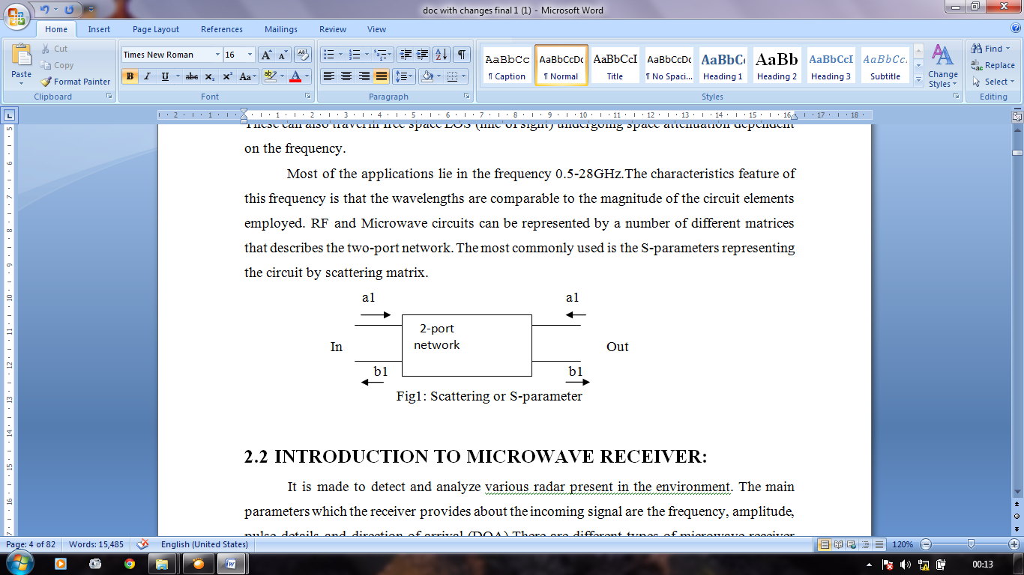

Figure 3.1: Scattering or S-parameter

* 1. **INTRODUCTION TO MICROWAVE RECEIVER**

It is made to detect and analyse, various radar present in the environment. The main parameters which the receiver provides about the incoming signal are the frequency, amplitude, pulse details and Direction of Arrival (DOA).There are different types of microwave receiver and each one is specific in its role to suit different applications.

A microwave receiver usually consists of a receiving antenna, a RF receiver-Front-End, Intermediate Frequency module, a Video Processing section and a Digital-Processing block. Mostly all the signal parameters are derived from the basic measurement of amplitude (through crystal detector) and phase (through phase detector) of the incoming signal. From the amplitude information, Amplitude-Based Direction Finding (ADF) and all the details of the pulsed signal are derived. From the phase information, the Instantaneous Frequency Measurement (IFM) and Phase-Based Direction Finding (PDF) details are derived. Receivers which are amplitude centred employ linear amplifier followed by a log-video amplifier for extending the dynamic range by measuring the amplitude. For the phase-based measurement, limiting amplifier is used instead of linear amplifier along with a phase detector.

Receiver specifications have reached close to the ideal situation. All the services expect that the receiver should be able to detect all types of signals at all frequencies with extremely good sensitivity and 100% Probability of Intercept (POI). The receiver should be able to detect any kind of multiple simultaneous signals including very weak signal in the presence of very strong signals. It should be very compact, light-weight, low power consumption and cost effective.

* 1. **Classification of receivers based on realization of Ideal Receiver System**

1. **Conventional Receiver:** Classification is based on narrow bandwidth (crystal video receiver, homodyne receiver) coverage with high sensitivity.
2. **Compressive Receiver:** Similar to heterodyne for rapid tuning characteristics, delay proportional to frequency, fast tuned LO to convert the RF into FM.
3. **Bragg Cell Receivers:** An instantaneous spectrum analyzer capable of handling multiple signals. Uses optical processing technique to derive the frequency information of multiple signals through Fourier series after passing through Bragg.

* 1. **CONVENTIONAL RECEIVERS**

These are classified based on two major techniques. The feature of first category is narrow bandwidth coverage with high sensitivity and the second category is wide bandwidth with low sensitivity. Super heterodyne receiver and Channelized receiver etc. are of narrow bandwidth type whereas Crystal video receiver, Homodyne receiver etc. are of wide bandwidth type.

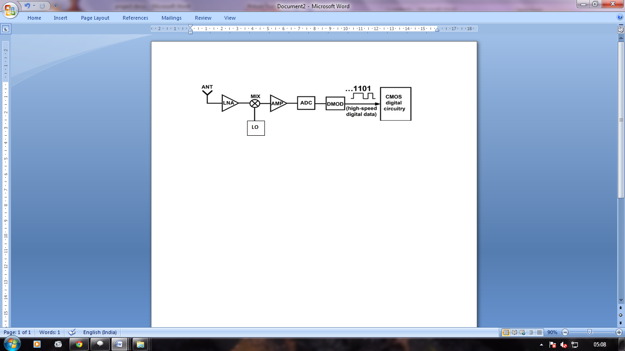

Figure 3.2: Conventional Receiver

* 1. **SUPER HETERODYNE RECEIVER**

EDWIN H.ARMSTRONG has invented a super heterodyne receiver in 1918. Widely used for communication and Electronic warfare (EW) systems. Uses down conversionprinciple to improve sensitivity. The sensitivity improvement up to -90dBm or better is achieved by increasing the signal amplification gain and reducing the noise band width.

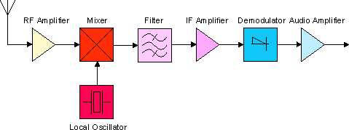

Figure 3.3: Principle of Super Heterodyne Receiver

* + 1. **PRINCIPLE OF OPERATION**

A mixer, a Local oscillator (LO), an Intermediate Frequency (IF) filter and amplifier, video/phase detector are the essential components of the receiver. This receiver transforms the information of a portion of RF frequency into an IF band using a tuned LO. The tuning of LO is mechanically ganged to the tuning of signal circuit or radio frequency (RF) stages so that the difference intermediate frequency is always the same fixed value. In this approach the IF is much lower than the input RF frequency and is often called down conversion approach. Usually a tuneable band pass filter is used as a pre-selector filter before the pre amplifier or mixer to avoid and isolate the interfering from the other part of the wide RF bandwidth.

I.F=R.F±L.O

* + 1. **SALIENT FEATURES AND CRITICALITY**

1. Very high sensitivity and selectivity.
2. Easy realization of the operational gain and filtering in lower IF band.
3. Sensitivity can be minimized by controlling the intermodulation products of the mixer and by adjustment of RF preamplifier gain and IF amplifier gain.
   * 1. **APPLICATIONS**
4. Detection of signal presence in all the pulse parameters and instantaneous frequency measurement.
5. Detection of low strength signals from long range.
6. Amplitude based direction of arrival are some of the important applications.
7. **MICROWAVE CONTROL COMPONENTS**

Microwave components are categorized into narrow and broadband components. The narrow band components find use in radar and imaging applications. The broad band components are used in electronic warfare systems.

Another Classification of components is based on power handling namely low power (<1W), medium power (average of 10W) and high power. Microwave system will require some nonlinear and active components such devices include diodes, transistors and tubes which can be used for detection, mixing, amplification, frequency, multiplication, switching and as sources. There are two types of components namely:

1. Components for conditioning the RF signal such as amplifiers, mixers, frequency translators and detectors.
2. Components for controlling the RF signal such as switches, limiters, phase shifters and attenuators etc.

The active as well as passive components can be realized in different transmission mediums. Some of the Microwave Components are shown in the below figure.

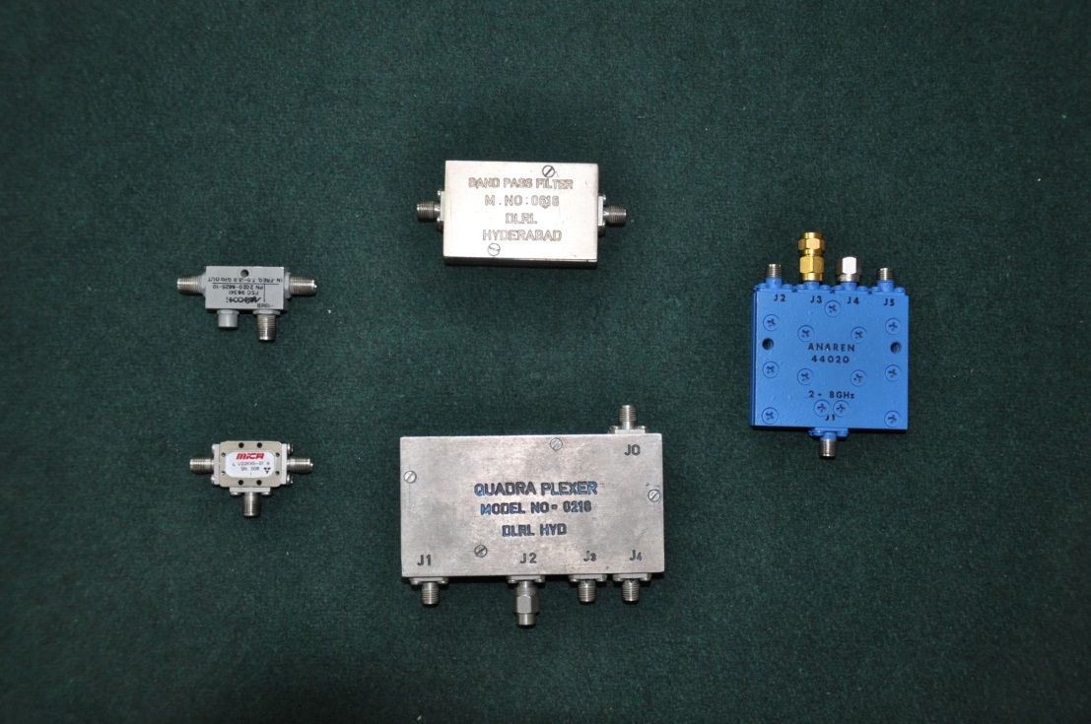

Figure 4.1: Microwave Control Components

1. **ISOLATOR**

An isolator is a [two-port](http://en.wikipedia.org/wiki/Two-port_network) device that transmits [microwave](http://en.wikipedia.org/wiki/Microwave) or [radio frequency](http://en.wikipedia.org/wiki/Radio_frequency) power in one direction only. It is used to shield equipment on its input side, from the effects of conditions on its output side; for example, to prevent a microwave source being detuned by a mismatched load.

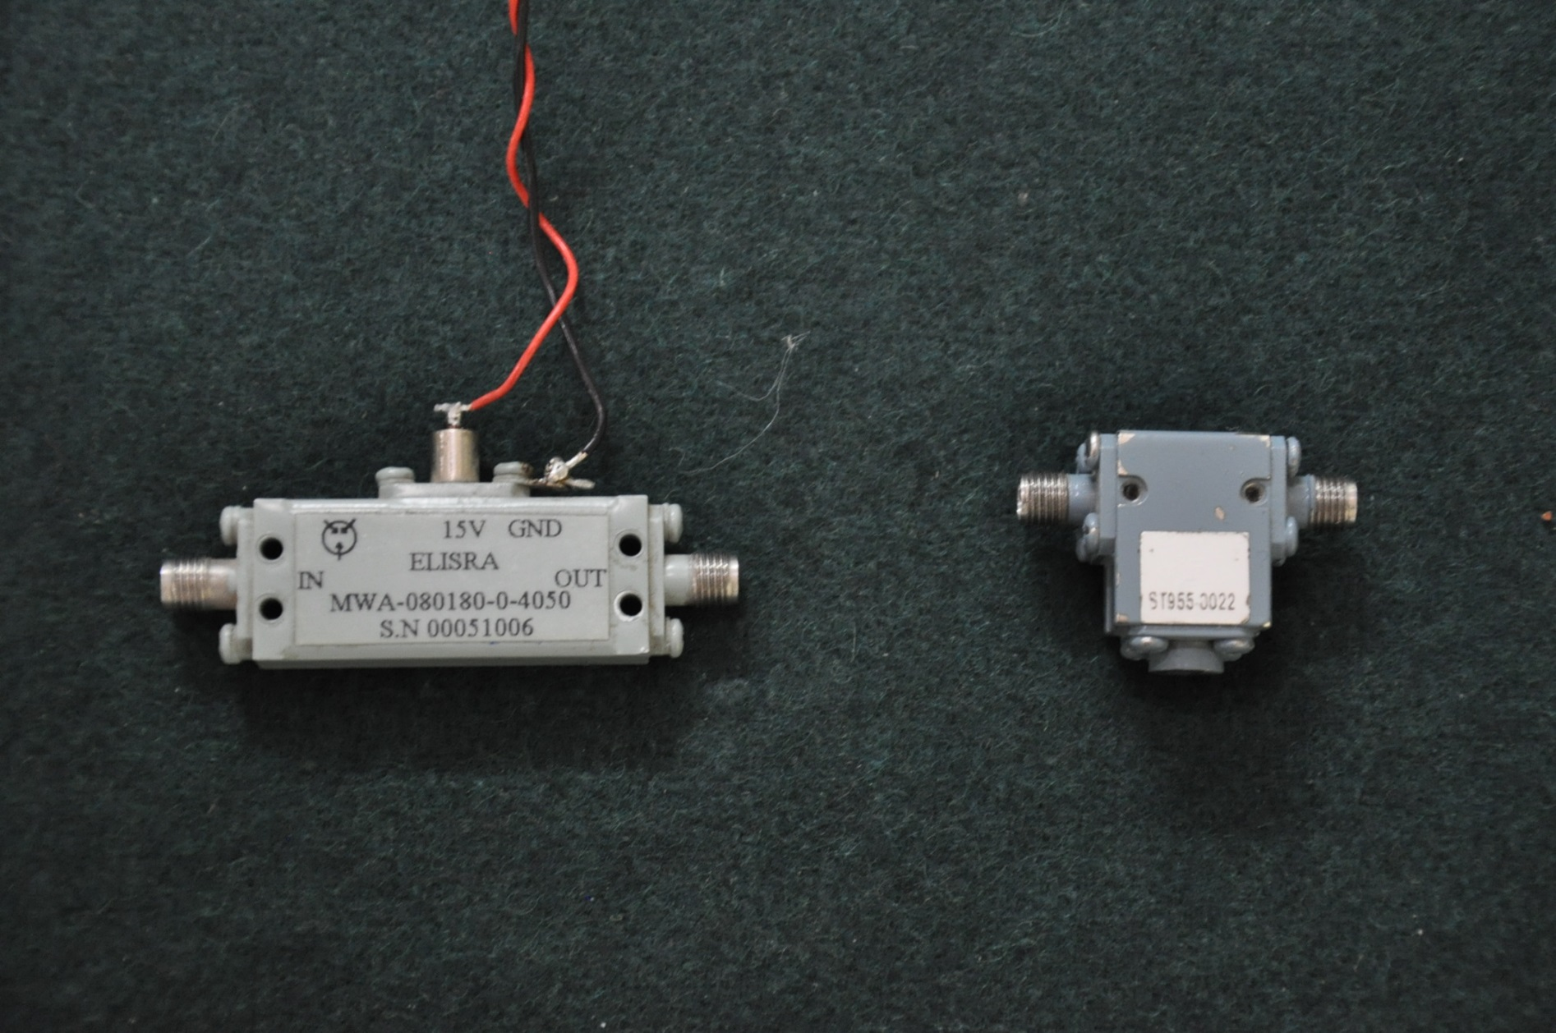

Figure 5.1: Isolator

**SPECIFICATIONS OF ISOLATOR**

* Frequency : 8-18GHz
* Insertion loss : 1dB max
* Isolation : 20db min
* Power handling : +2dBm
* VSWR : 1.5 max
* Operational Temperature : 00C - 550Cmax

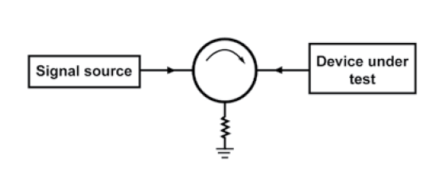

Figure 5.2: Schematic of Isolator

* 1. **THE MAIN PARAMETERS OF ISOLATOR**

**Isolation:**

An important consideration when specifying an isolator or circulator is to ensure the device has adequate isolation for your given application. Isolation is a unit of measure (in dB) that states the separation of signal levels on adjacent ports of a device. The greater the isolation value, the less interference from a signal on one port relative to an adjacent port. The amount of isolation is directly affected by the VSWR presented at port 3 of the isolator. If the match on port 3 is poor, you can expected isolation below 10 dB, but if the match is improved to 1.10:1 by using a good termination device in the circuit, then the isolation would improve to over 20 dB. In some applications greater isolation is required (30 to 40dB). In these situations a dual junction isolator is used.

**Insertion Loss:**

Another important consideration when specifying a circulator or isolator is to ensure the device has minimal insertion loss when inserted in a transmission path. Generally, the insertion loss of a circulator or isolator (or any microwave device for that matter) becomes more significant at higher frequency, namely because loss increases with frequency and higher frequency power sources are considerably more expensive. Accordingly, the criteria of low insertion loss will prevent precious power from being wasted.The isolator is placed in the measurement path of a test bench between a signal source and the device under test (DUT) so that any reflections caused by any mismatches will end up at the termination of the isolator and not back into the signal source.

Insertion Loss (dB) =

* 1. **Experimental Aspects of Isolator**

The experimental Aspects of the component are the test results of the devices that are mainly observed in the testing to match the component specification. The Isolator have two tests mainly Insertion loss and Isolation.

* + 1. **Test for Insertion Loss**

Signal Source

Isolator

Spectrum Analyzer

Port 1

Port 2

Figure 5.3: Setup for testing Insertion loss of Isolator

Input Power = 0dBm, Cable Loss = 2dBm.

|  |  |  |
| --- | --- | --- |
| **Frequency (GHz)** | **Output Power (dBm)** | **Insertion Loss(dBm)** |
| 8  9  10  11  12  13  14  15  16  17  18 | -3.09  -3.62  -3.02  -4.32  -3.82  -3.22  -4.09  -2.93  -3.31  -3.37  -3.79 | -1.09  -1.62  -1.02  -2.32  -1.82  -1.22  -1.09  -0.93  -1.31  -1.37  -1.79 |

Table 5.1: Test Results for Insertion Loss of Isolator

* + 1. **Test for Isolation**

Signal Source

Isolator

Spectrum Analyzer

Port 1

Port 2

Figure 5.4: Setup for testing Isolation of Isolator

Input Power = 0dBm, Cable Loss = 2dBm.

|  |  |  |
| --- | --- | --- |
| **Frequency (GHz)** | **Output Power (dBm)** | **Insertion Loss(dBm)** |
| 8  9  10  11  12  13  14  15  16  17  18 | -38.2  -22.8  -19.92  -21.66  -25.12  -31.9  -24.9  -21.09  -22.9  -29.01  -22.4 | -36.2  -20.8  -17.92  -19.66  -23.12  -28.9  -22.9  -19.09  -20.09  -27.08  -20.04 |

Table 5.2: Test Results for Isolation of Isolator

1. **ATTENUATOR**

An attenuator is an [electronic device](http://en.wikipedia.org/wiki/Electronic_device) that reduces the [power](http://en.wikipedia.org/wiki/Electric_power) of a [signal](http://en.wikipedia.org/wiki/Signal_(information_theory)) without appreciably [distorting](http://en.wikipedia.org/wiki/Distortion) its [waveform](http://en.wikipedia.org/wiki/Waveform). An attenuator is effectively the opposite of an [amplifier](http://en.wikipedia.org/wiki/Amplifier), though the two work by different methods. While an amplifierprovides [gain](http://en.wikipedia.org/wiki/Gain), an attenuator provides loss, or gain less than 1.

Attenuators are usually [passive devices](http://en.wikipedia.org/wiki/Passive_device) made from simple [voltage divider](http://en.wikipedia.org/wiki/Voltage_divider)networks. [Switching](http://en.wikipedia.org/wiki/Switch) between different resistances forms adjustable steppedattenuators and continuously adjustable ones using [potentiometers](http://en.wikipedia.org/wiki/Potentiometer). For higherfrequencies precisely matched low [VSWR](http://en.wikipedia.org/wiki/VSWR) [resistance](http://en.wikipedia.org/wiki/Electrical_resistance) networks are used.

Fixed attenuators in circuits are used to lower voltage, [dissipate](http://en.wikipedia.org/wiki/Dissipation) power, and toimprove [impedance matching](http://en.wikipedia.org/wiki/Impedance_matching). In measuring signals, attenuator pads or adaptors areused to lower the [amplitude](http://en.wikipedia.org/wiki/Amplitude) of the signal a known amount to enable measurements,or to protect the measuring device from signal levels that might damage it.Attenuators are also used to 'match' impedances by lowering apparent SWR.

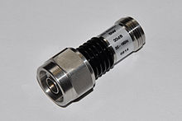

Figure 6.1: Attenuator

* 1. **RF Attenuators**

Radio frequency attenuators are typically coaxial in structure with precision connectors as ports and coaxial, microstrip or thin-film internal structure. Above [SHF](http://en.wikipedia.org/wiki/Super_high_frequency) special waveguide structure is required.

Important characteristics are:

1. Accuracy,
2. Low SWR,
3. Flat Frequency-Response and
4. Repeatability.

The size and shape of the attenuator depends on its ability to dissipate power. RF attenuators are used as loads for and as known attenuations and protective dissipations of power in measuring RF signals.

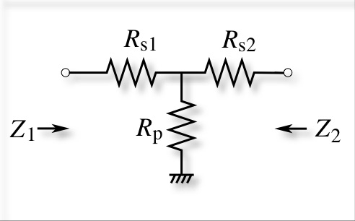

Figure 6.2: T-type Attenuator

RF attenuators are a universal building block within the RF design arena. The name implies RF attenuators reduce the level of the signal. This may be required to protect a stage from receiving a signal level that is too high, an attenuator may be used to provide an accurate impedance match as most fixed attenuators offer a well-defined impedance, or attenuators may be used in a variety of areas where signal levels need to be controlled.

## TYPES OF RF ATTENUATORS

RF attenuators can be categorised in a number of ways according to their capabilities and the technologies they use.

1. **Fixed RF attenuator:** The name implies fixed attenuators have a specific value and this cannot be changed.
2. **Switched RF attenuators:** These attenuators are widely used in test systems where levels may need to be changed.
3. **Variable RF attenuators:** These attenuators provide a continuous level change by varying an analogue voltage on the input control line. These are normally used in applications where it is necessary to continuously vary the level of a signal.

Signal Source

Attenuator

Spectrum Analyzer

Port 2

Port 1

Figure 6.3: Set up for testing Attenuator

* 1. **Specifications**
* Frequency : 6-18 GHz
* Attenuation : 10dB
* Attenuation accuracy : 0.5dB
* VSWR : 1.2max
* Temperature : -540C to +1250C

1. **BAND PASS FILTERS**

A band-pass filter is a device that passes [frequencies](http://en.wikipedia.org/wiki/Frequency) within a certain range and rejects ([attenuates](http://en.wikipedia.org/wiki/Attenuate)) frequencies outside that range. Band pass filter has a pass band and a stop band. A dual band pass filter has two pass bands. A band pass signal is a signal containing a band of frequencies away from zero frequency, such as a signal that comes out of a band pass filter. An ideal band pass filter would have a completely flat [pass band](http://en.wikipedia.org/wiki/Passband) (e.g. with no gain/attenuation throughout) and would completely attenuate all frequencies outside the pass band. Additionally, the transition out of the pass band would be instantaneous in frequency. In practice, no band pass filter is ideal. The filter does not attenuate all frequencies outside the desired frequency range completely; in particular, there is a region just outside the intended pass band where frequencies are attenuated, but not rejected. This is known as the filter [roll-off](http://en.wikipedia.org/wiki/Roll-off), and it is usually expressed in [dB](http://en.wikipedia.org/wiki/Decibel) of attenuation per [octave](http://en.wikipedia.org/wiki/Octave_(electronics)) or [decade](http://en.wikipedia.org/wiki/Decade_(log_scale)) of frequency.

The [bandwidth](http://en.wikipedia.org/wiki/Bandwidth_(signal_processing)) of the filter is simply the difference between the upper and lower [cut-offfrequencies](http://en.wikipedia.org/wiki/Cutoff_frequency). The shape factor is the ratio of bandwidths measured using two differentattenuation values to determine the cut-off frequency, e.g., a shape factor of 2:1 at 30/3 dBmeans the bandwidth measured between frequencies at 30 dB attenuation is twice thatmeasured between frequencies at 3 dB attenuation.

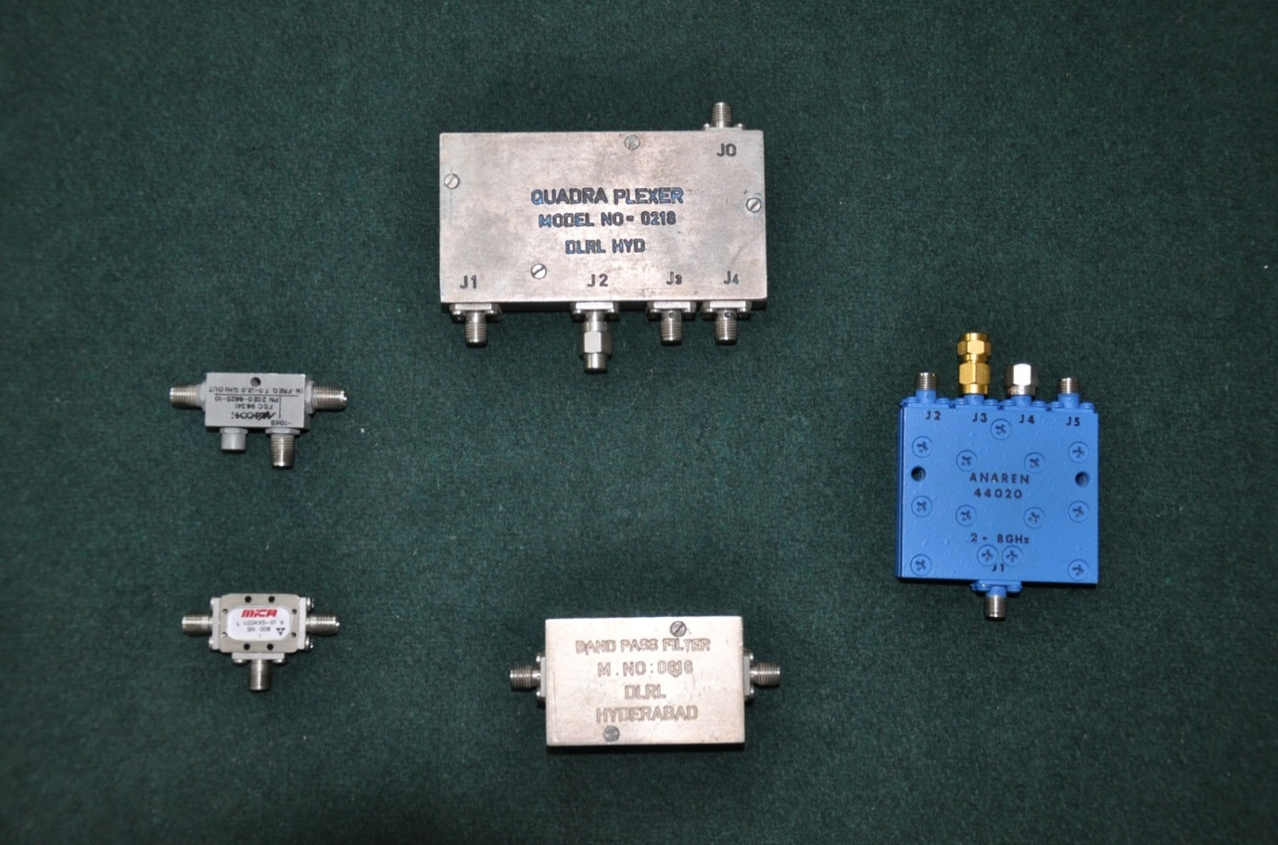

Figure 7.1: Band Pass Filter

* 1. **DESIGN OF BANDPASS FILTER**

The performance of an electronic filter can determine whether the system is successful. The range of signal frequencies that are allowed to pass through a filter, with little or no change to the signal level, is called the pass band.

Many of the filter design methods will make use of lumped element low pass prototype filters. Most of the low pass, high pass, band pass and band stop microwave filters will derive their important transmission characteristics from those of low pass prototype filter used in their design.

The image impedance and attenuation function of a filter section are defined in terms of an infinite chain of identifier sections connected together. Using finite sections, dissipation less filter network with resistor terminations will permit the image impedance to be matched only at discrete frequencies, and the reflection effects can cause sizeable attenuation in the pass band, as well as distortion of the stop band edges.

One way to improve the pass band response is by using different principles in designing of end sections which reduce this mismatch of image impedance and in turn reduces the reflection effects.

* 1. **PROCEDURE OF FILTER DESIGNING**

Filter specifications include the cut-off frequency, the stop band attenuation, the pass band insertion loss, the pass band behaviour etc.

1. Design a low pass “Prototype” circuit. In such a Prototype, R = 1 Ω and ωc = 1 rad/s, filter tables are used for this step, or perhaps a computer package.
2. Scale and conversion. Finally, the filter is scaled to the proper impedance level and air desired, to a high pass, band pass or band stop topology.
   1. **PARAMETERS IN THE FILTER DESIGN**

The figure shows the basic block diagram of a filter fed by a source and terminated by a load. Pi is the incident power at the filter input, Pr is the reflected power and Pl is the power passed onto the load.

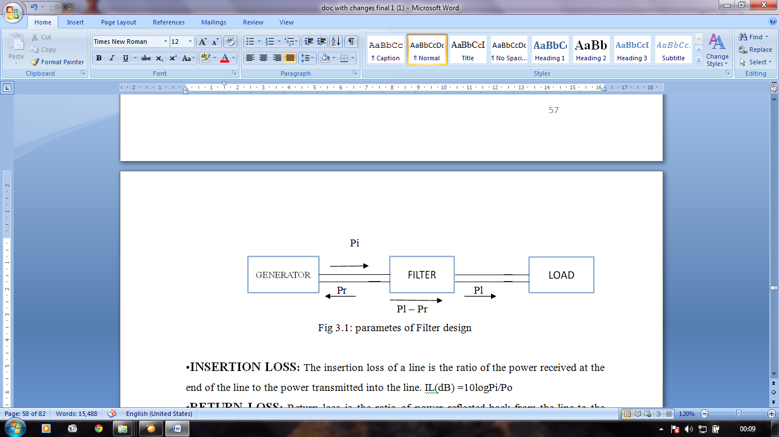

Figure 7.2: Parameters of Filter Design

1. **INSERTION LOSS:** The insertion loss of a line is the ratio of the powerreceived at the end of the line to the power transmitted into the line.

Insertion Loss (dB) =10logPi/Po

1. **RETURN LOSS:** Return loss is the ratio of power reflected back from the line to the power transmitted into the line. RL= 10log Pr/Pi
2. **TRANSMISSION LOSS:** 10log (Pi-Pr)/ Po
3. **REFLECTION LOSS:** 10log Pi/ (Pi-Pr)
   1. **FILTER TYPES BASED ON CIRCUIT ELEMENTS**

Two types of microwave filters are there according to electrical circuit type

1. Lumped filters
2. Distributed filters
   * 1. **LUMPED ELEMENT FILTERS**

The size of lumped-circuit element, by definition, is very much smaller than the operating wavelength, and therefore exhibits negligible phase shift. Lumped element filters have the advantage of smaller size, lower cost, and wide-band characteristics. The design of lumped element filters is well established but the physical realization of lumped networks at microwave frequencies is complicated because of the limited range of practical values and topology requirements. The two basic building blocks for filter design –inductors and capacitors are available in lumped forms. Computer-aided designs of filters using lumped elements require a complete and accurate characterization of lumped elements at microwave frequencies.

This necessitates the development of models that take into account proximity effects, parasitic, ground plane effects. Straight sections of ribbons and wires are used for low inductance values typically between 2-3 nH. Spiral inductors have higher Q and can provide higher inductance values. The free space inductance L (in Nano henrys) of a wire of diameter d and length ℓ (in microns) is given by

$$L\left(nH\right)=2*{10}^{-4}*l*\left\{\ln\left(\frac{4l}{d}\right)+\frac{d}{2l}-\frac{3}{4}\right\}$$

A lumped capacitor may be visualized as small length of an open circuited line. The most common form of capacitor generally used at microwave frequencies is MIM capacitors used in chip form or can be fabricated by sandwiching a thin layer of dielectric between two parallel plate conductors. The overall unloaded Q of the structure is about 150 –200 and depends on the absolute frequency. The capacitors and inductive coils are soldered to a microwave substrate, which is etched to produce interconnection and bonding pads. The substrate is bonded to the metal housing.

* + 1. **DISTRIBUTED ELEMENT FILTERS**

The distributed element filters are realized commonly by using coupled line or transmission line as circuit elements. The design of filter using distributed circuit is done using Richards transformation, which establishes simple relationship between lumped and distributed elements. The following relation defines the Richards frequency transformation.

$$s=jω=jtan(\frac{πf}{2f_{r}})$$

Where frrepresents the frequency at which all the transmission lines are one quarter wavelength long (βℓ = π / 2). The variable ω ranges from zero to infinity when frequency is varied from zero to f. The transmission line version is realized simply by replacing all inductors in the lumped element filter by shorted lines, all capacitors by open circuited lines with line lengths equal to quarter wavelength at fr.

* 1. **FILTER TRANSFORMATION**

The prototype low pass filter for maximally flat/ Chebyshev, and elliptical shown above has the source and load impedance at 1and the upper edge of the pass band at 1 rad/s. However all these prototypes can be scaled to any frequency and can be transformed into any of the four types Low pass filter (LPF),High pass filter( HPF),Band pass filter( BPF) and Band rejection filter(BRF). The required transformation from low pass prototype filter with cut-off at w1’ =1 and terminated in 1source and load impedance into HPF, BPF, BRF with arbitrary source and load impedance Z0.

**7.5.1 BAND PASS TRANSFORMATION**

Assume that a low pass prototype response is to be transformed to a band pass response having a pass band ω2 – ω1, where ω1 and ω2 indicate the pass band-edge angular frequency. The required frequency transformation is

Ω = $\frac{Ω_{c}}{FBW}\left(\frac{ω}{ω_{0}}-\frac{ω_{0}}{ω}\right)$

FBW= $\frac{ω_{2}-ω_{1}}{ω_{0}}$

$ω_{0}$ = $\sqrt{ω_{1}ω_{2}}$

Where $ω$ 0 denotes the center angular frequency and *FBW* is defined as the fractional bandwidth. If we apply this frequency transformation to a reactive element *g* of the lowpass prototype, we have



$$jΩg→jω\frac{Ω_{c}g}{FBWω_{0}}+ \frac{1}{jω}\frac{Ω_{c}ω_{0}g}{FBW}$$

Figure:Low pass prototype to band pass transformation: (a) Basic element transformation, (b) A practical high pass filter based on the transformation.

This implies that an inductive/capacitive element ‘g’ in the low pass prototype will transform to a series/parallel LC resonant circuit in the band pass filter. The elements for the series *LC* resonator in the band pass filter are

$$L_{s}=\left(\frac{Ω_{c}}{FBWω_{0}}\right)γ_{0}g$$

$$C_{s}= \left(\frac{FBW}{ω_{0}Ω_{c}}\right)\frac{1}{γ_{0}g}$$

For ‘g’representing the Inductance

Where, the impedance scaling has been taken into account as well. Similarly, the elements for the parallel *LC* resonator in the band pass filter are

$$C_{p}=\left(\frac{Ω_{c}}{FBWω_{0}}\right)\frac{g}{γ_{0}}$$

$$L_{p}= \left(\frac{FBW}{ω_{0}Ω_{c}}\right)\frac{γ_{0}}{g}$$

For ‘g’representing the Capacitance

It should be noted that and

* 1. **FILTER REALIZATION**

The filters can be realized in any medium, such as microstrip, stripline, suspended stripline, coaxial line, and as well as in waveguide depending on their applications. Filters or Filter banks can be realized by using lumped as well as printed circuit configuration. Each has its own advantages and disadvantages. Lumped filter banks will have the advantage of small size, spurious free response, but have poor electrical performance (especially at high frequencies due to very low Q factor), low power handling and less reproducibility, whereas the printed filter bank configuration will provide rugged design (very good reproducibility), much better electrical performance (at high frequencies also), better power handling capability. But it suffers from spurious generations; mutual coupling between the adjacent filters and has bigger size than what is achievable in case of a lumped filter.

* 1. **LUMPED ELEMENT FILTER TECHNOLOGY**

Lumped element filters are designed by using two methods. These are

1. Image parameter method
2. Insertion loss method
   * 1. **IMAGE PARAMETER METHOD**

Image parameter method uses network consists of a cascade of simpler two port filter sections to provide the cut-off frequencies and attenuation characteristics, but do not allow the specifications of a frequency response over the complete operating range.

* + 1. **INSERTION PARAMETER METHOD**

Insertion loss method uses network synthesis techniques to design filters with a completely specified frequency response. The design is simplified by beginning with low pass filter prototype that normalized in terms of impedance and frequency.

Transformations are then applied to convert the prototype designs to the desired frequency range and impedance level.

* 1. **FILTER DESIGN**

A filter design consists of three phases:

1. Approximation
2. Synthesis and analysis
3. Realization

The starting point of any filter design is the selection of that prototype characteristics function which, most closely approximates to the required characteristics.

* + 1. **SYNTHESIS AND ANALYSIS**

Several methods are available for synthesizing filters. One of the most common and successful method is form low pass prototype network. This method consists of the following steps:

1. Design of a low pass prototype filter with desired pass band characteristics.
2. Transformation of this prototype network to the required type (LPF, HPF,BPF,BSF)
3. Realization of the network in terms of lumped and/or distributed circuit elements.
4. Filter transformation

The prototype l pf has the source and load impedance at 1Ω and the upper edge of the pass band at 1 rad/sec. However, all these prototypes can be scaled to any frequency and can be transformed. The required transformation from low pass prototype filter with cut-off at $ω_{1}$ =1 and terminated in 1ohm source and load impedance into BPF with arbitrary source and load impedance ‘ $Z_{0}$’.

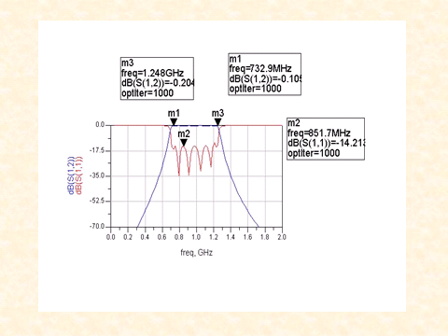

Figure 7.3: Band Pass Filter Plot

1. **TRIPLEXER**

Triplexers split a wide frequency band intoa number of signals of different frequencyranges. The separation of the desired frequencybands can be achieved by using bandpassfilters combined at a common input.

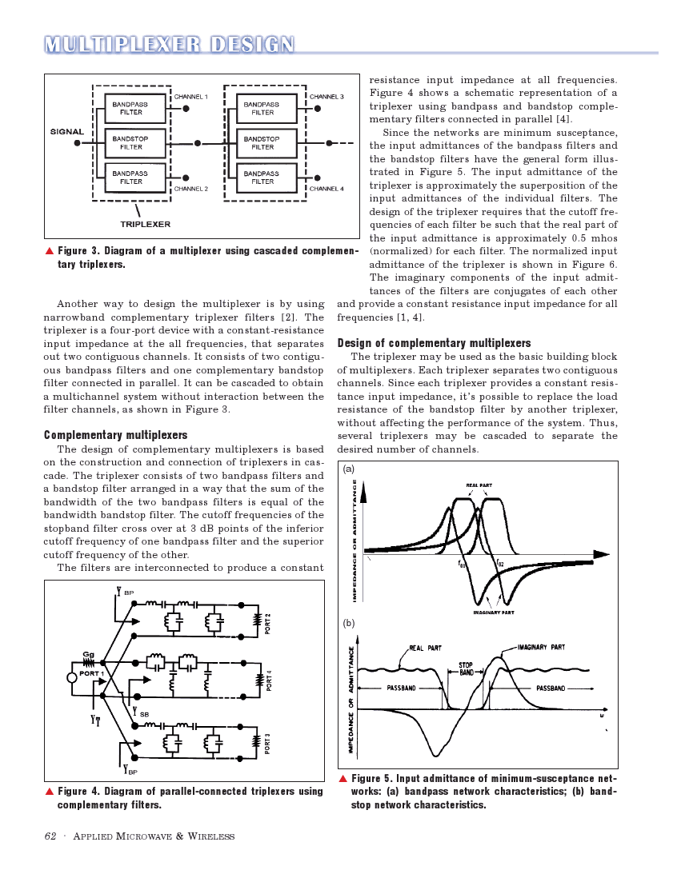

Figure 8.1: Triplexer Schematic

The triplexer consists of two bandpass filters anda bandstop filter arranged in a way thatthe sum of thebandwidth of the two bandpass filters is equal of thebandwidth bandstopfilter. The cut-off frequencies of thestopband filter cross over at 3 dB points of the inferiorcut-off frequency of one bandpass filter and the superiorcut-off frequency of the other.

The Triplexer consists of three series quarter-wavelength transmission lines, three band pass filters, and three transmission lines for tuning of the filter impedance. The principle of operation is that each sub-band has matched input impedance (50 Ω in this design) at the junction, but high input impedance at the input of other sub-bands.

The series transmission lines of three different quarter wavelengths provide high impedance at the respective frequency band, i.e., preventing sub-band 1 signals to reach sub-band 2 and 3. The filter tuning lines at the junctions optimize the stop band impedance of each filter, to provide high stop band impedance in the neighboring bands.

Neighboring sub-bands are most critical to a sub-band since the band-pass filter has limited rejection close to its pass-band. The entire network is optimized together with the filters to achieve flat pass bands and a symmetric performance between the sub-bands.

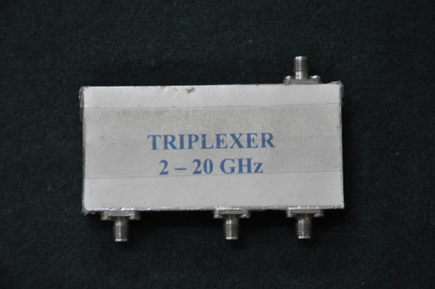

Figure 8.2: Triplexer

There are many types of multiplexers are present, some of them are:

1. Diplexer
2. Triplexer
3. Quadraplexer

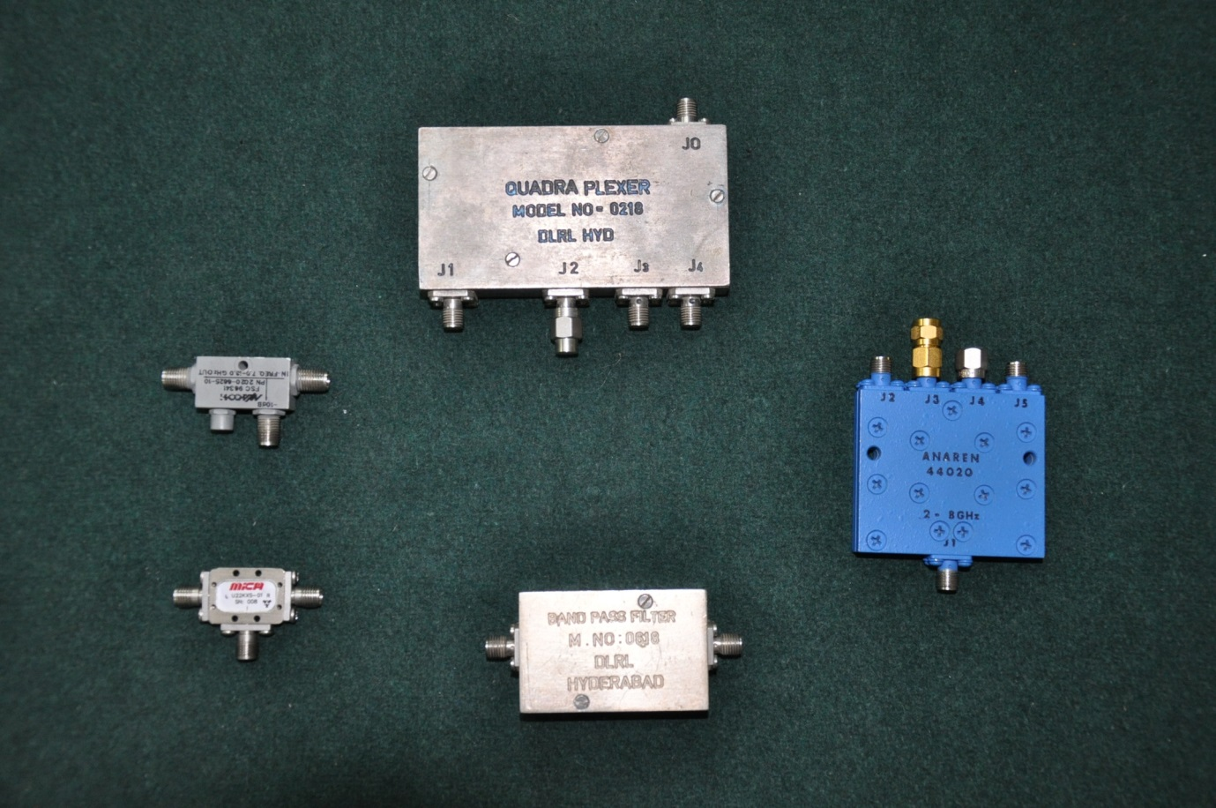

Figure 8.3: Quadraplexer

Specifications of Triplexer:

* Frequency: 2GHz to 20GHz
* Insertion Loss : 2dB
* Return Loss : 12dB
* Each Band : 6 GHz
  1. **EXPERIMENTAL ASPECTS OF TRIPLEXER**

Triplexer

Spectrum Analyzer

Input

Band 1

Band 2

Band 3

MT

MT

2 GHz to 20GHz

* + 1. **Test for Band 1**

2 – 8GHz

8 – 14GHz

14 – 20GHz

Figure 8.4: Test for Triplexer in Band 1

Input Power: 0dBm, Input frequency range for Band 1: 2GHz to 8GHz

|  |  |
| --- | --- |
| **Frequency (GHz)** | **Output Power (dBm)** |
| 2.0  2.5  3.0  3.5  4.0  4.5  5  5.5  6  6.5  7  7.5  8  8.5 | -33.05  -11.05  -10.92  -11.61  -12.71  -15.21  -11.36  -10.31  -7.03  -4.37  -4.73  -5.61  -22.22  -49.17 |

Table 8.1: Triplexer Band 1 results

* + 1. **Test for Band 2**

Triplexer

Spectrum Analyzer

Input

Band 1

Band 2

Band 3

MT

MT

2 GHz to 20GHz

2 – 8GHz

8 – 14GHz

14 – 20GHz

Figure 8.5: Test for Triplexer in Band 2

Input Power: 0dBm, Input frequency range for Band 2: 8 GHz to 14 GHz

|  |  |
| --- | --- |
| **Frequency (GHz)** | **Output Power (dBm)** |
| 7.5  8  8.5  9  9.5  10  10.5  11  11.5  12  12.5  13  13.5  14  14.5 | -50.03  -35.3  -4.30  -4.57  -4.3  -9.34  -8.76  -5.07  -3.85  -6.34  -5.07  -4.02  -7.8  -18.2  -41.5 |

Table 8.2: Triplexer Band 2 results

* + 1. **Test for Band 3**

Triplexer

Spectrum Analyzer

Input

Band 1

Band 2

Band 3

MT

MT

2 GHz to 20GHz

2 – 8GHz

8 – 14GHz

14 – 20GHz

Figure 8.6: Test for Triplexer in Band 3

Input Power: 0dBm, Input frequency range for Band 3: 14 GHz to 20 GHz

|  |  |
| --- | --- |
| **Frequency (GHz)** | **Output Power (dBm)** |
| 13.5  14  14.5  15  15.5  16  16.5  17  17.5  18  18.5 | -36.7  -17.1  -17.99  -16.93  -15.5  -16.97  -15.6  -14.52  -16.69  -16.32  -16.3 |

Table 8.3: Triplexer Band 3 results

1. **POWER DIVIDER**

A microwave power divider is a passive device, which will divide the input signal into a number of equiphase outputs. In general, all of the outputs have equal amplitudes; however, some times the outputs are of different amplitudes. It can be used to combine several signals together and in this application, it is often referred to as a power combiner. The general requirements of a power divider are wide frequency bandwidth, low input and output VSWR’s, and good isolations between different outputs. A change in any of the o/p circuits is felt immediately at all of the remaining ports.

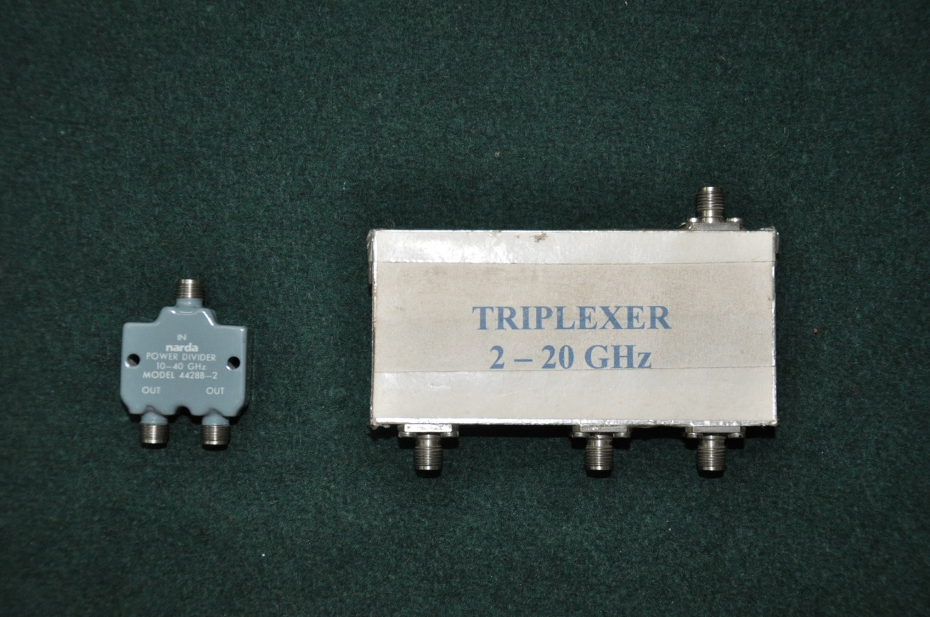

Figure 9.1: Power Divider

Various RF applications require power to be distributed amongvarious paths. Thesimplest way this can be done is by using a power splitter/divider. Power dividers are reciprocal devices, i.e. they can also be used to combine power from output ports into the input port. The two main categories of power dividers are, reactive and resistive, with each suited for its own specific application.

* 1. **RESISTIVE POWER DIVIDERS**

Resistive power splitters have inherent characteristics that make them anexcellent choice for certain applications but unsuitable for others. Below figure shows the layout of a simple 2-Way resistive power divider. Zo denotes the characteristic impedance of the system.



Figure 9.2: Layout of 2-Way resistive divider

Calculations:

Resistor values for an N-way resistive divider:

R = Zo * ( ( N-1)/(N+1) )

Where, Zo is the characteristic impedance of the system.

Transferred power ratio = ${\left(1/N\right)}^{2}$

A resistive power divider has a power ratio of ${\left(1/N\right)}^{2}$ (where N is the number of outputs) when compared toa reactive power divider which has a power ration of 1/N. This means for a 2-Way divider with 1 watt input power, a reactive unit’s output port will have 0.5 watts (50% or 3 dB loss) of power on each port, while a resistive divider’s output will have 0.25 watts (25% or 6 dB loss) of power on each port. Resistive divider’s loss includes distribution loss and inherent resistive loss, unlike the “lossless” reactive dividers (which only have distribution loss). So as a general rule, insertion loss of a resistive power divider is double that of a similar reactive unit.

In a resistive power divider, Insertion Loss = Isolation.

* 1. **REACTIVE POWER DIVIDER**

Reactive power dividers come in various forms and cover a wide range of frequencies. They can have multiple output ports, but those with odd number of output ports are usually referred to as N way power dividers. They can be realized using waveguide, stripline, microstrip, transformer and various other technologies. These dividers come in in-phase, ${180}^{o}$ out of phase ( ${180}^{o}$ hybrids), ${90}^{o}$ out of phase (quadrature hybrids) and other specialized configurations. One of the main advantages of using reactive power dividers is that they are “lossless”. Table gives the number of output ports and the insertion loss that is associated with them.

Below figure shows the general layout of a 2-Way Power divider. Higher order devices like (4, 6, 8 way etc.) are usually realized by cascading the 2 way in various configurations. The other figure shows the layout of a N way power divider (a 3 way is shown). Note that all ports connected in a manner that makes them mutually isolated from one another.



Figure 9.3: Layout of 2-Way Power Divider



Figure 9.4: Layout of 3-Way Power Divider

* 1. **THE WILKINSON POWER DIVIDER**

At higher frequencies (above 500 MHz) these devices are usually realized as a microstrip Or stripline Wilkinson design. All Broad wave reactive power dividers are Wilkinson types. Below figure shows a simple 2-Way Wilkinson power divider. Being a lossless Reciprocal three port network, it inherits all its properties which state that this type of network cannot have all the ports simultaneously matched. To solve this isolating resistor is placed between the two output ports, since no current flows through the resistor (there is no potential difference between the output ports), this resistor does not contribute to any resistive loss. This makes an ideal Wilkinson a 100% efficient device. This resistor also provides excellent isolation even when the device is used as a combiner. Another property of the Wilkinson divider is that it is broken down into quarter wavelength (l/4) sections.

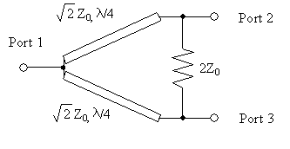

Figure 9.5: 2-Way Wilkinson power divider

When choosing a power dividers, here are some key parameters need to consider.

**Frequency Range (Hz):** This is application specific.

**VSWR:** Voltage Standing Wave Ratio (VSWR) is the ratio of maximum and minimum voltage at a given point along a transmission line. VSWR is a good measure of power transfer efficiency. A low VSWR (i.e. closer to unity with little or no reflections) means more power is delivered from the source to the load, while a high VSWR ( i.e. much greater than 1 with lots of reflection within unit) has less power delivered to the load.

**Insertion Loss (dB):** Insertion loss is the decrease in the transmitted signal power due to the insertion of a device in a transmission line. It is defined as the ratio of the output to input power.

**Coupling Factor (dB):** Ratio of power transferred to coupled port with respect to the input port.

**Isolation (dB):** Ratio of input power with respect to power at isolated port or vice versa. The output ports of the divider are isolated from one another ( the input port is isolated from the output port if the unit is used as a combiner) by the isolating resistor. Ideally no current flows through the resistor as the ports are of the same potential, but if non-identical signals which are out of phase are combined a voltage differential is formed between the ports causing current to flow through the resistor, reducing the isolation. Isolation is a critical factor when determining interference or “crosstalk” between the ports.

**Amplitude tracking (dB):** The difference between the amplitude of the output signals measured at the output ports of the dividers. It is defined as the ratio of the maximum amplitude of signal at any port to the minimum of any other ports, expressed in decibels. This is also sometimes specified as amplitude balance (or imbalance).

**Phase Tracking (degrees):** The maximum deviation, from theoretical value, between the phase measured between two output signals. This is also sometimes specified as phase balance (or imbalance).

**Octave Bands (Hz):** A doubling in frequency is represented by an octave. 1-2 GHz is an octave, while 8-12 GHz is half an octave.

**Input Power (W):** Both average and peak power need to be taken into account when choosing a divider.

|  |  |
| --- | --- |
| **No. of output ports (N)** | **Insertion Loss (dB)** |
| 2  3  4  5  6  8  10  .N | 3.01  4.77  6.02  7  7.78  9.03  10  10log(N) |

Table 9.1: Number of Power Divider outputs vs. corresponding Insertion Loss

* 1. **EXPERIMENTAL ASPECTS OF 2-WAY POWER DIVIDER**

The Experimental Aspects are the test results taken from the devices. The 2-way power divider has three tests namely, finding output power of port1, port2, and isolation of the Power Divider.

* + 1. **POWER DIVIDER PORT 1 OUTPUT**

Spectrum Analyzer

MT

POWER DIVIDER

SIGNAL SOURCE

P2

P1

Figure 9.6: Test setup for Power Divider Port 1 Output

Input power: 0 dBm

|  |  |  |  |
| --- | --- | --- | --- |
| **Frequency (GHz)** | **Output Power (dBm)** | **Cable Loss (dBm)** | **Insertion Loss (dBm)** |
| 8  9  10  11  12  13  14  15  16  17  18 | -5.02  -5.39  -4.57  -4.69  -5.34  -5.98  -5.84  -5.47  -5.45  -5.78  -5.73 | -1.58  -2.46  -1.38  -2.19  -2.38  -3.12  -2.53  -2.53  -2.25  -2.71  -2.41 | -3.44  -3.13  -3.1  -2.5  -3  -2.86  -3.32  -2.94  -3.2  -3.07  -3.32 |

Table 9.2: Test Result for Power Divider Port 1 Output

* + 1. **POWER DIVIDER PORT 2 OUTPUT**

In this test we are terminating port1 of the power divider and the input is given from input port and the output is taken from the port 2. The reading of the spectrum analyzer gives the insertion loss of the power divider for a port.

Spectrum Analyzer

MT

POWER DIVIDER

SIGNAL SOURCE

P2

P1

Figure 9.7: Test setup for Power Divider Port 2 Output

Input power: 0 dBm

|  |  |  |  |
| --- | --- | --- | --- |
| **Frequency (GHz)** | **Output Power (dBm)** | **Cable Loss (dBm)** | **Insertion Loss (dBm)** |
| 8  9  10  11  12  13  14  15  16  17  18 | -4.71  -5.25  -4.42  -4.59  -4.96  -5.98  -6.07  -5.63  -5.48  -5.59  -5.82 | -1.58  -2.46  -1.38  -2.19  -2.38  -3.12  -2.53  -2.53  -2.25  -2.71  -2.41 | -3.13  -2.79  -3.04  -2.4  -2.62  -2.84  -3.54  -3.1  -3.23  -2.88  -3.41 |

Table 9.3: Test Result for Power Divider Port 2 Output

* + 1. **POWER DIVIDER ISOLATION**

In this test we are terminating the input port of the Power Divider and the signal source is given from the port 2 and the output is taken from the port 1 to the spectrum analyzer. The isolation must be higher as shown in the specifications.

MT

Spectrum Analyzer

POWER DIVIDER

SIGNAL SOURCE

P1

P2

Figure 9.8: Test setup for Power Divider Isolation

Input power: 0 dBm

|  |  |
| --- | --- |
| **Frequency (GHz)** | **Isolation**  **(dBm)** |
| 8  9  10  11  12  13  14  15  16  17  18 | -19.81  -15.91  -9.54  -18.45  -22.16  -11.79  -16.26  -15.5  -10.12  -15.26  -13.53 |

Table 9.4: Test Result for Power Divider Isolation

1. **SWITCH**

There are two fundamental methods of connecting PIN diodes to transmission line to provide a switching function in series with transmission lines so that RF power is conducted when the PIN diode is forward biased and reflected when reverse biased or in shunt with the transmission line so that the RF power conducted when the diode id reverse biased and reflected when forward biased .A simple reflective SPST switch can be designed utilizing one or more PIN diodes.

A multi throw switch essentially consist of SPST switches connected a common junction andbiased so that each switch port can be enabled individually .The common junction of the switch must designed to minimize the resistive and reactive loading presented by the OFF port in order to obtain low insertion loss VSWR for the ON port . There are two basic methods of realizing a multi throw switch common junction optimum performance over a broad frequency range the first employees series mounted PIN diodes connected to thecommon junction .A path is selected by forward biasing its series diode and simultaneously areverse biasing all other diodes this provides the desired low loss path for the ON port withminimum of loading from the OFF ports. The second method utilizes sent mounted PINdiodes located a quarter wavelength from the junction.

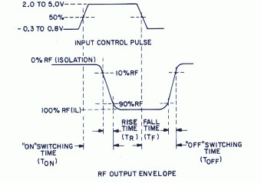

Figure 10.1: Switching timing of the switch

The diodes of the selected ON port isreverse biased while OFF ports of forward biased to create a short circuit across thetransmission line .As a result of the quarter wavelength spacing, the short circuits aretransformed to open circuits at the junction .by proper choice of the transmission lineimpedances and minimization of stray reactance it is possible to construct a switch of thistype with low insertion loss and VSWR over a 3-1 band width.

Switches can be broadly classified as Electromechanical, Ferrite, PIN diode and Monolithic Microwave Integrated Circuit (MMIC) based.

1. Electromechanical switches have excellent RF performance, can be madein waveguide or coaxial form and can handle high powers, but are bulkyand suffer in terms of slow switching speed and reliability.
2. Ferrite switches are bulky and suffer from temperature sensitivity.
3. MMIC switches have the advantage of faster switching speed and low dc power consumptions but they have the disadvantage of limited power handling and limited isolation in multiport switches.
4. PIN diode switches have the advantage of faster switching speed due to the efficient means of removing speed charge, thus ensuring rapid switching between forward and reverse bias states, high reliability and medium power handling capability.
   1. **CATEGORIZING MICROWAVE SWITCHES:**

Switches are classified according to class, function, and diode configuration. All switches fall into one of two distinct classes

* Reflective
* Non reflective

Reflective switches reflect incident power back to the source when in the isolated state. Non- reflective switches are designed to terminate any incident power in the isolated state. Either of the switches connect source to a load when in the insertion loss state.

Both switch categories can be divided into three groups according to their function. Single-pole single throw(SPST), single-pole multi throw (SPMT) and transfer switches. An SPST switch is a two-port device,which either connects the source to the load or isolates Source from the load. An SPMT switch is a multi-port device, which can connect a source and any one of different loads.

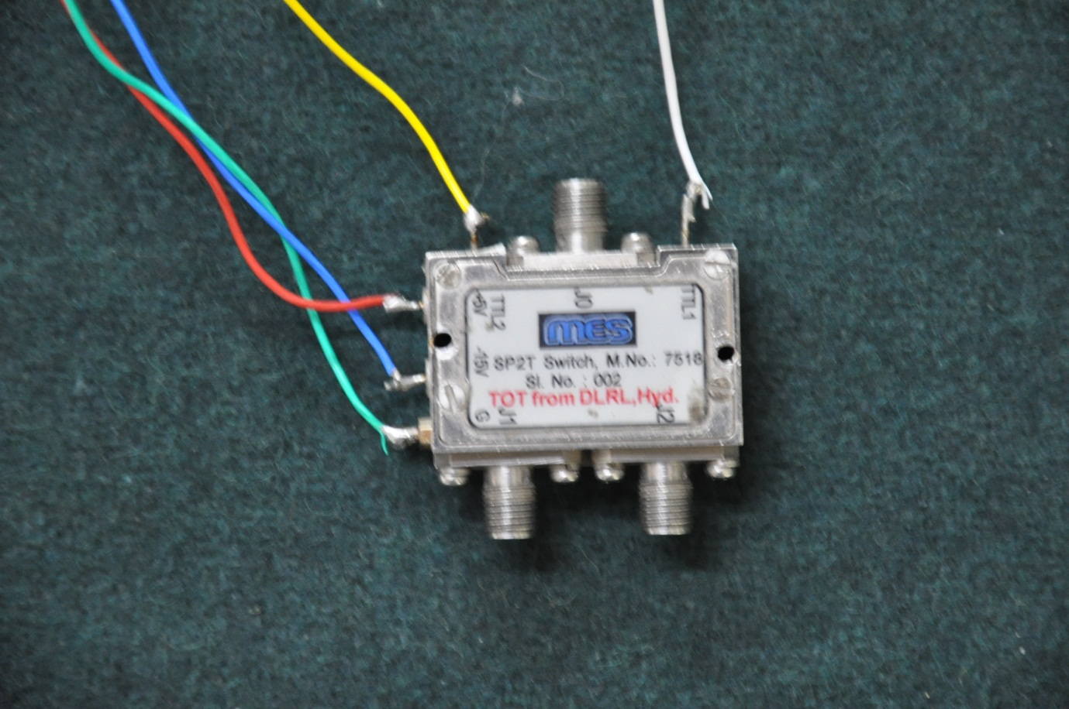

Figure 10.2: Electronic Switch SP2T

**SPECIFICATIONS:**

* Frequency : 6-18GHz
* Insertion Loss : 2dB(max)
* Isolation : 45dB(min)
* Power Supply : +5V,-15V,GND
* Switching Speed : 25nsec
* Power Handling : 1W
* Temperature : 0º -55ºcentigrade
* Logic : 0 is ON & 1 is OFF

1. **AMPLIFIER**

In most of the receiving systems the signal present at the input of the receiver is very weak. It needs enough amplification for processing and getting information. The amplifier while increasing the signal strength should not introduce or generate more noise by itself. These types of amplifiers, also known as low noise amplifiers are required at the receiver front end where the signal strength is very low. The output power of a low noise amplifier varies linearly with the input power. Medium power amplifiers with output power levels of the order of +10 to +30dBm are required to drive Travelling wave tubes (TWT’s), solid-state high power amplifiers, mixers, multiple phase correlators etc.

The next category is power amplifier; the output of these amplifiers drives the transmitting antenna of Radars, jammers, base stations, Cell phones etc. The power output of these power amplifiers may be few watts in the case of Cell phones to kilowatts in Radars and jammers.

There is another kind of microwave amplifier known as limiting amplifier. The main feature of this amplifier is that the output remains constant within few dB for a large variation in the input power level. Limiting amplifiers are necessary in IFMs, frequency memory loops, phase measurement receivers etc. Microwave amplifiers into three groups namely low noise amplifiers, power amplifiers and limiting amplifiers. A microwave amplifier would have the following specifications:

Frequency Range, Gain and gain flatness, Noise figure, Output power at 1dB gain compression, saturated power output, Input reflection coefficient, Output reflection coefficient, Bias voltage and current and size connector type etc.

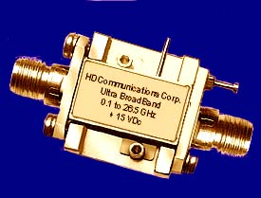

Figure 11.1: Amplifier

* 1. **LOW NOISE AMPLIFIER**

Generally, an amplifier or simply amp is a device for increasing the [power](http://en.wikipedia.org/wiki/Power_(physics)) of a [signal](http://en.wikipedia.org/wiki/Signal_(information_theory)) by use of an external energy source. In popular use, the term usually describes an [electronic amplifier](http://en.wikipedia.org/wiki/Electronic_amplifier), in which the input "signal" is usually a voltage or a current. In [audio](http://en.wikipedia.org/wiki/Sound_recording_and_reproduction) applications, amplifiers drive the [loudspeakers](http://en.wikipedia.org/wiki/Loudspeaker) used in [PA systems](http://en.wikipedia.org/wiki/PA_system) to make the human voice louder or play recorded music.

The quality of an amplifier can be characterized by a number of specifications, listed below.

* + 1. **GAIN**

The [gain](http://en.wikipedia.org/wiki/Gain) of an amplifier is the [ratio](http://en.wikipedia.org/wiki/Ratio) of output to input power or amplitude, and is usually measured in [decibels](http://en.wikipedia.org/wiki/Decibel). (When measured in decibels it is [logarithmically](http://en.wikipedia.org/wiki/Logarithm) related to the power ratio.

Power ratio: *G*(dB)=10 log(*Pout* /*Pin*)

[RF](http://en.wikipedia.org/wiki/Radio_Frequency) amplifiers are often specified in terms of the maximum power gain obtainable, while the [voltage](http://en.wikipedia.org/wiki/Voltage) gain of audio amplifiers and [instrumentation amplifiers](http://en.wikipedia.org/wiki/Instrumentation_amplifier) will be more often specified (since the amplifier's [input impedance](http://en.wikipedia.org/wiki/Input_impedance) will often be much higher than the source impedance, and the load impedance higher than the amplifier's output impedance).

* + 1. **BANDWIDTH**

The [bandwidth](http://en.wikipedia.org/wiki/Bandwidth_(signal_processing)) of an amplifier is the range of frequencies for which the amplifier gives "satisfactory performance". The definition of "satisfactory performance" may be different for different applications. However, a common and well-accepted metric is the [half power points](http://en.wikipedia.org/wiki/Half_power_point) (i.e. frequency where the power goes down by half its peak value) on the output vs. frequency curve. Therefore bandwidth can be defined as the difference between the lower and upper half power points. This is therefore also known as the −3 dB bandwidth.

* + 1. **LINEARITY**

An ideal amplifier would be a totally linear device, but real amplifiers are only linear within limits. When the signal drive to the amplifier is increased, the output also increases until a point is reached where some part of the amplifier becomes saturated and cannot produce any more output; this is called clipping, and results in [distortion](http://en.wikipedia.org/wiki/Distortion).

In most amplifiers a reduction in gain takes place before hard clipping occurs; the result is a *compression* effect, which (if the amplifier is an audio amplifier) sounds much less unpleasant to the ear. For these amplifiers, the 1 dB compression point is defined as the input power (or output power) where the gain is 1 dB less than the small signal gain. Sometimes this nonlinearity is deliberately designed in to reduce the audible unpleasantness of hard clipping under overload.

IP ll effects of nonlinearity can be reduced with negative feedback.

[Linearization](http://en.wikipedia.org/wiki/Linearization) is an emergent field, and there are many techniques, such as feed forward, [predistortion](http://en.wikipedia.org/wiki/Predistortion), post distortion, in order to avoid the undesired effects of the non-linearity’s.

* + 1. **NOISE**

This is a measure of how much [noise](http://en.wikipedia.org/wiki/Noise) is introduced in the amplification process. Noise is an undesirable but inevitable product of the electronic devices and components; also, much noise results from intentional economies of manufacture and design time. The metric for noise performance of a circuit is [noise figure](http://en.wikipedia.org/wiki/Noise_figure) or noise factor. Noise figure is a comparison between the output signal to noise ratio and the thermal noise of the input signal.

* + 1. **OUTPUT DYNAMIC RANGE**

Output [dynamic range](http://en.wikipedia.org/wiki/Dynamic_range) is the range, usually given in dB, between the smallest and largest useful output levels. The lowest useful level is limited by output [noise](http://en.wikipedia.org/wiki/Noise), while the largest is limited most often by distortion. The ratio of these two is quoted as the amplifier dynamic range. More precisely, if *S* = maximal allowed signal power and *N* = noise power, the dynamic range *DR*.

*DR = (S + N) /N*

In many switched mode amplifiers, dynamic range is limited by the minimum output step size.

* + 1. **SLEW RATE**

[Slew rate](http://en.wikipedia.org/wiki/Slew_rate) is the maximum rate of change of the output, usually quoted in volts per second (or microsecond). Many amplifiers are ultimately [slew rate](http://en.wikipedia.org/wiki/Slew_rate) limited (typically by the impedance of a drive current having to overcome capacitive effects at some point in the circuit), which sometimes limits the full [power bandwidth](http://en.wikipedia.org/wiki/Power_bandwidth) to frequencies well below the amplifier's small-signal frequency response.

* + 1. **NOISE FIGURE**

In a microwave amplifier, even when there is no input signal, a small output voltage can be measured and that output power is named as the amplifier noise power.

Total noise output power = The amplified noise input power + The noise output power produced by the amplifier.

The noise figure (F) describes quantitatively the performance of a microwave amplifier. The noise figure of a microwave amplifier is defined as the ratio of the total available noise power at the output of the amplifier to the available noise power at the input due to thermal noise at the input. The Noise Figure can be expressed in the form

$$F=\frac{PN_{O}}{PN_{i}G_{A}}= \frac{{PS_{i}}/{PN_{i}}}{{PS_{O}}/{PN_{O}}}$$

Where, $PN_{O}$ is the total available noise power at the output of amplifier

$PS_{i}$ Is the available signal power at the input.

$G_{A}$ Is the gain of the amplifier.

$PN_{i}$ Is the input noise power.

$PS_{O}$ Is the output signal power.

* + 1. **ONE dB GAIN COMPRESSION POINT**

The 1dB gain compression point (called $G_{1}$ dB) is defined as the power gain where the non-linearties of the transistors reduce the power gain by 1 dB over the small – signal linear power gain. i.e.,

$$G_{1}\left(dB\right)= G_{0}\left(dB\right)-1$$

Where, $G_{0}$ (dB) is the small – signal linear power gain in decibels.

Since the power gain is defined as $G_{p}$ = ${P_{out}}/{P_{in}}$. Dynamic range is the range of input or output power with linear gain. At low powers this is limited by the noise figure or the minimum detectable signal, and at high powers it is limited by the power level where small-signal gain has been compressed by 1 dB.

When two signals close in frequency are present in the amplifier, a third–order product will appear in the pass band at $2f_{2}-f_{1}$ or $2f_{1}-f_{2}$ as a result of the nonlinear components of gm. Since the intercept point of the 3rd-order two - tone products is usually 10 dB gain compression point, the spurious free dynamic range can be calculated graphically.

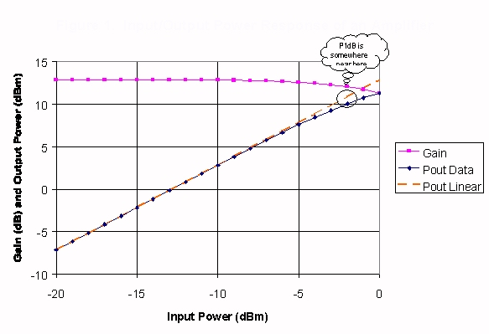

Figure 11.2: One dB Compression point

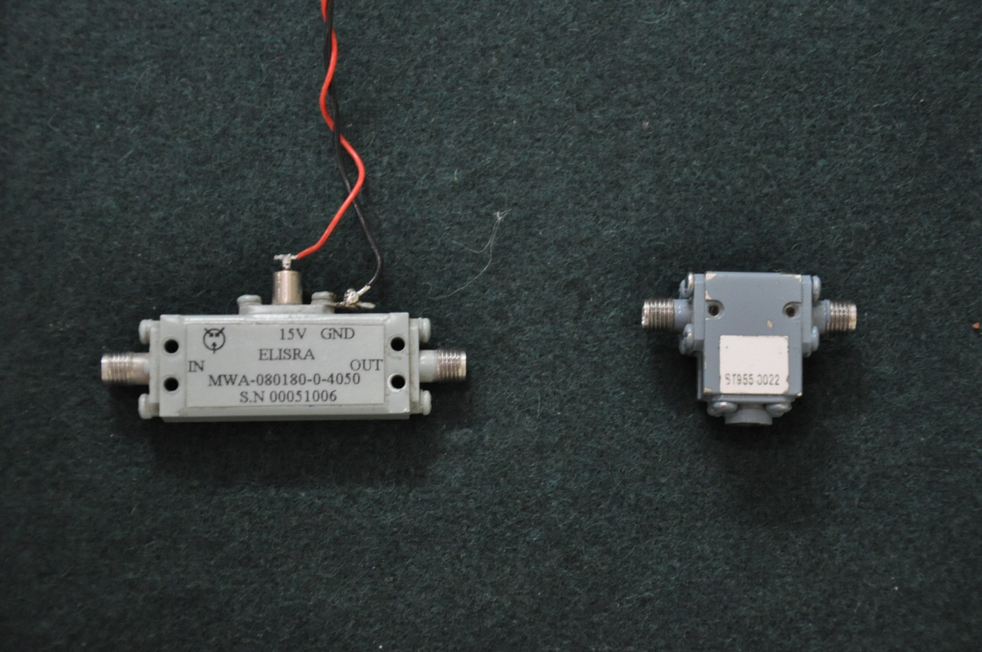

Figure 11.3: Low Noise Amplifier

**Specifications:**

* Frequency : 8 GHz – 18 GHz
* Gain : 40 dB
* 1 dB Compression Point : 15dB
* Input upper level : 1 dB compression point – gain
* Input lower level :Input upper level – 20 dB
  1. **EXPERIMENTAL ASPECTS OF LOW NOISE AMPLIFIER**

At constant frequency by giving different input powers we are calculating the output powers and gain and also compare this output values with theoretical values of microwave receiver front end in Ku band and also the final readings are given below.

* + 1. **GAIN MEASURMENT**

For measurement of the gain of the low noise amplifier, taking the input gain as constant with -30 dBm, and by varying the input frequency from 8 GHz – 18 GHz note the output power from the amplifier seen from the spectrum analyser.

The bench setup for testing the Low Noise Amplifier is shown in the below figure.

For the testing of this component we have the signal source, isolator having the insertion loss of 1dBm, Low Noise Amplifier with gain of 40dBm and the spectrum analyser to see the output power.

Spectrum Analyzer

LOW

NOISE

AMPLIFIER

SIGNAL SOURCE

GND

+15V

ISOLATOR

Figure 11.4: Test setup for Low Noise Amplifier

Gain Measurement

Input Power = -30 dBm

|  |  |  |
| --- | --- | --- |
| **Frequency (GHz)** | **Output Power (dBm)** | **Gain (output - input)** |
| 8  8.5  9  9.5  10  10.5  11  11.5  12  12.5  13  13.5  14  14.5  15  15.5  16  16.5  17  17.5  18 | 7.75  8.76  7.59  7.25  7.29  6.04  4.57  4.90  4.24  5.38  5.50  5.75  5.09  5.46  6.27  7.52  7.98  7.74  6.59  5.85  6.27 | 40  41.76  40.59  40.25  40.29  39.04  37.57  37.9  37.24  38.38  38.5  38.75  38.09  38.46  39.27  40.52  40.98  40.74  39.59  38.85  39.27 |

Table 11.1: Test results for LNA Gain Measurement

* + 1. **ONE dB COMPRESSION POINT**

Frequency = 12 GHz

|  |  |  |
| --- | --- | --- |
| **Input Power (dBm)** | **Output Power (dBm)** | **Gain** |
| -45  -44  -43  -42  -41  -40  -39  -38  -37  -36  -35  -34  -33  -32  -31  -30  -29  -28  -27  -26  -25  -24  -23  -22  -21  -20  -19  -18  -17  -16  -15  -14 | -5.49  -4.59  -3.61  -2.76  -1.80  -0.80  0.21  1.22  2.25  3.28  4.40  5.27  6.25  7.01  8.03  9.0  10.11  11.17  12.17  13.11  14.27  15.63  16.11  16.53  16.83  17.28  17.49  17.81  17.98  18.21  18.28  18.30 | 39.51  39.41  39.39  39.24  39.2 39.2  39.21  39.22  39.25  39.28  39.40  39.27  39.25  39.01  39.03  39.0  39.11  39.17  39.17  39.11  39.27  39.63  39.11  38.53  37.38  37.28  36.49  35.81  34.98  34.21  33.28  32.3 |

Table 11.2: Test results for 1 dB Compression Point

1. **MIXER**

Mixers are three ports active or passive devices are designed to yield both a sum and a difference frequency at a single output port when two distinct input frequencies are inserted into the other two ports. This process, called frequency conversion (or heterodyning), is found in most communication’s gear, and is used so that we may increase or decrease a signal’s frequency. One of the two input frequencies will normally be a CW wave, produced within the receiver by a local oscillator (LO) i.e., DRO, while the other input will be the RF signal received from the antenna.

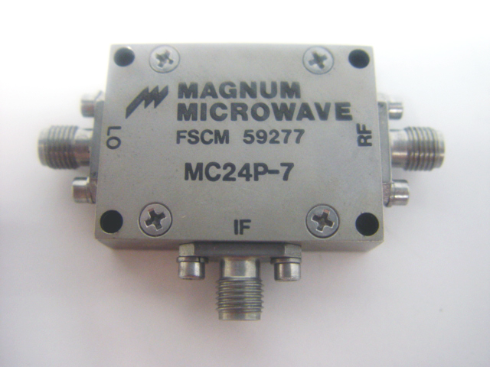

Figure 12.1: MIXER

* 1. **MIXER THEORY**

To achieve frequency conversion, a periodic signal having frequency, $f_{R}$, is modulated by a periodic conductance (or resistance) waveform having frequency, $f_{L}$. The current resulting from the RF voltage being modulated by the fundamental component of the conductance waveform contains the sum and difference.

IF products: $f_{R}$ + $f_{L}$ and $f_{R}$- $f_{L}$ or $f_{L}$- $f_{R}$.

The other undesired currents generated are intermodulation products having frequencies of n $f_{L}$ ± ${ f}_{R}$, where n is an integer. Inter-modulation products have also been referred to as idlers. In the case of an active mixer, one having conversion gain, the conductance waveform is that of one or more transistors. In the case of a passive mixer, which has conversion loss, the conductance waveform is generally that of one or more Schottky-barrier diodes. Increasingly, however, MESFET devices have been used instead of diodes to achieve wider dynamic range in passive mixers.

Analysis of the frequency conversion properties of mixers is non-trivial. The simplest model, which perhaps gives the best intuitive understanding of the mixing process is the linear phase-reversal mixer.

This model assumes the diode is nonreactive and acts as a linear rectifier, having a square wave resistance waveform with zero forward and infinite backward resistances. The mixer is considered linear because the values of the circuit elements, including diode conductance, are independent of RF and LO levels. It has been shown that this model approximates the Schottky diode mixer closely enough to formulate theoretical limits for conversion-loss and intermodulation suppression [2, 3]. Figure 1 shows a conventional double-balanced diode mixer. During positive LO cycles, diodes D1 and D2 are turned on while D3 and D4 are off. The opposite is the case during negative LO cycles. This causes the RF (signal) voltage as seen by the IF port to change phase by 180 degrees every time the LO signal changes polarity. This can be represented mathematically by multiplying the sinusoidal signal voltage with the Fourier series for the square-wave switching function:

$V_{out}$ = $V_{RF}$ sin ($ω_{R}t$) [4/π Σ 1/n sin (n $ω_{L}t$)]

n=1,3,5...

= $V_{RF}$ 4/π {(1/2) [sin($ω_{L}$- $ω_{R}$)t - sin($ω_{R}$ + $ω_{L}$)t]

+ (1/6) [sin (3 $ω_{L}$- $ω_{R}$)t- sin (3 $ω_{L}$ + $ω_{R}$)t] + ...}

Conversion loss is equal to the reciprocal of conversion gain, and is defined as:

L = $\frac{Avalable RF Input Power}{Available IF Output Power}$

And RF-to-IF conversion loss is given by:

L = 20 $log\frac{V_{RF}}{V_{IF}}$

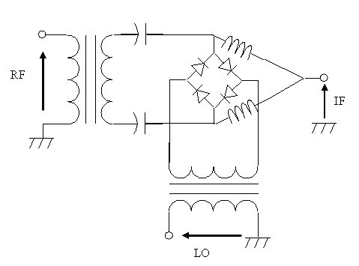

Figure 12.2: Schematic of a Mixer

* 1. **MIXER PARAMETERS AND OPTIMIZATION**

The major goals of mixer design are to minimize conversion loss, noise figure, and intermodulation distortion. Other important parameters to optimize include VSWR and compression.

* 1. **CONVERSION LOSS**

Conversion loss has three major components: RF and IF mismatch loss, loss in the diode spreading resistance, and loss in the diode junction due to junction resistance and generation of IM products. In double-balanced mixers, the RF input and image signals share the RF port, while the IF and sum products share the IF port. It has been shown that conversion loss can vary up to 2 dB by open or short circuiting the image. This method is used to reduce (enhance) mixer conversion loss.

* 1. **NOISE FIGURE**

The single sideband (SSB) noise figure is defined as:

NF = 10 log [$P_{n out}$/( $P_{n in}$ x G)]

= 10 log F

Where,

$P_{n out}$ = Available noise output power at IF frequency

$P_{n in}$ = Available noise input power at RF frequency

G = Available power gain (algebraic ratio)

F = Noise factor

The SSB noise factor is often described in terms of equivalent input noise temperature, $T_{mSSB}$:

F = 1 + $\frac{T_{mSSB}}{T_{0}}$

Where, $T_{0}$ = 290°K

Noise figure for passive devices is equal to the reciprocal of available power gain, as long as both the noise source and the passive device are at the same temperature. This implies that mixer noise figure equals conversion loss.

* 1. **INTERMODULATION**

Intermodulation (IM) distortion causes output products to be generated at frequencies of:

f = ± ${nf}_{L}$ ± ${m1f}_{R1}$ ± ${m2f}_{R2}$ ± ... (7)

Where,

n, m1, m2,... are integers. The value, n, is called the order of modulation, while the sum (|m1| + |m2| +...) is referred to as the order of intermodulation.

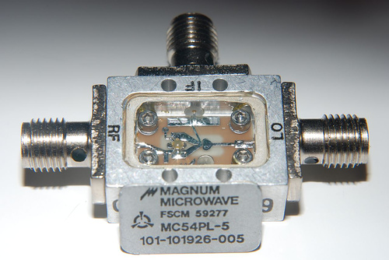

Figure 12.3: Internal of Mixer

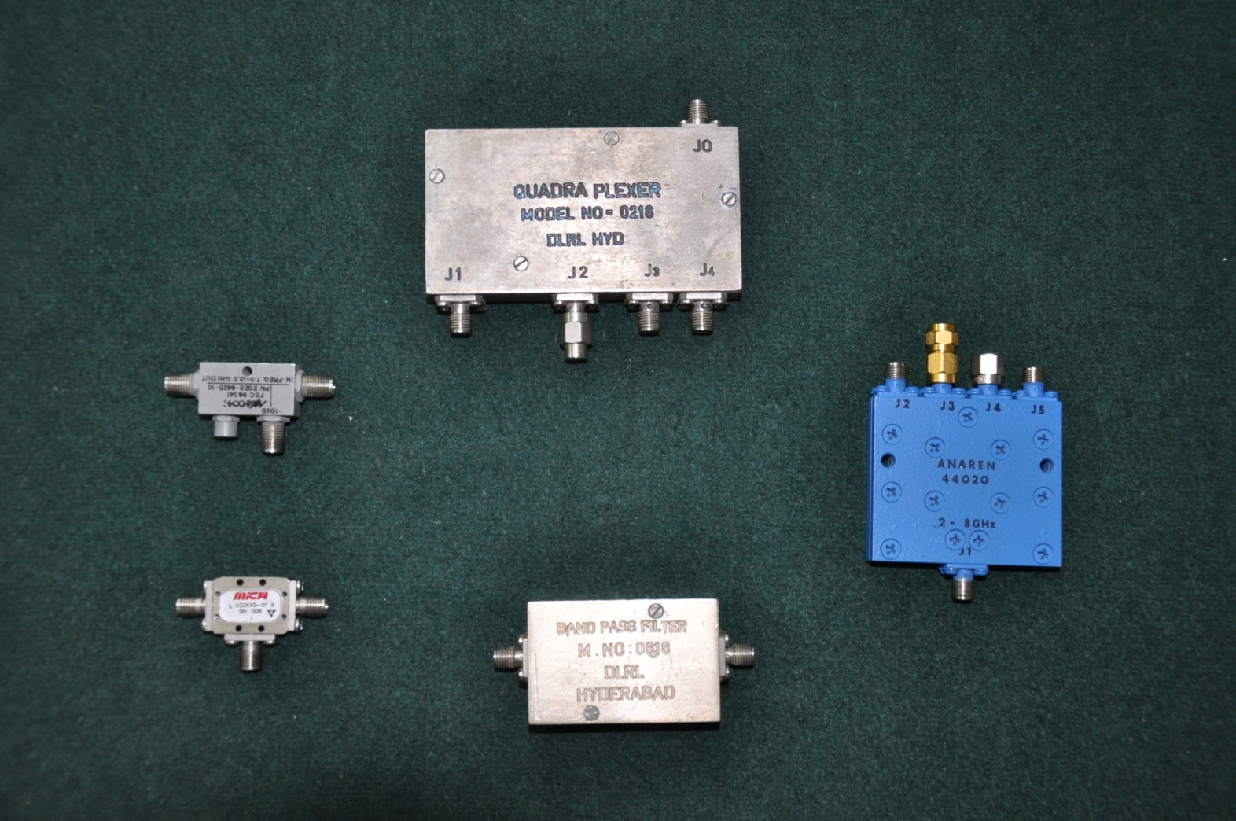

Figure 12.4: 10 dB Mixer

**Specifications:**

* LO : 4 GHz – 40 GHz
* RF : 4 GHz – 40 GHz
* IF : 0.5 GHz – 20 GHz
* Conversion Loss : 10 dBm max
* Isolation : RF → IF = 20dB

LO → RF = 23dB

LO → IF = 18dB

* 1. **EXPERIMENTAL ASPECTS OF MIXER**

Experimental Aspects relates to the testing and test results of the device. In the mixer there are four tests, namely, down conversion of the mixer, RF to IF Isolation, LO to IF Isolation,LO to RF Isolation.

* + 1. **Test for Down Conversion of Mixer:**

For down conversion test we are connecting the Mixer LO port to the DRO, RF to the Signal Source and the IF port to the Spectrum Analyzer.

Spectrum Analyzer

SIGNAL SOURCE

DRO

12 GHz, 17dB

Attenuator

(6dB)

MIXER

RF

IF

LO

Figure 12.5: Setup for Testing Down Conversion of a Mixer

Input RF Power = 0dBm

|  |  |  |
| --- | --- | --- |
| **RF in (GHz)** | **IF out (GHz)** | **Power (dBm)** |
| 8  9  10  11  12  13  14  15  16  17  18 | 4  3  2  1  0  1  2  3  4  5  6 | -9.2  -9.0  -8.5  -8.6  -0  -9.9  -9  -9.9  -11.4  -12  -11.9 |

Table 12.1: Test result for Mixer

* + 1. **Test for LO to IF Isolation:**

Isolation test is very important in the mixer as the port should not leak power in to the other port. In this test the LO is connected with the Signal Source and the Output is taken from the IF port of the Mixer to the Spectrum Analyser.

MT

Spectrum Analyzer

SIGNAL SOURCE

MIXER

LO

IF

RF

Figure 12.6: Setup for LO to IF Isolation

Input RF Power = 0dBm

|  |  |
| --- | --- |
| **Frequency (GHz)** | **Output Power (dBm)** |
| 8  9  10  11  12  13  14  15  16  17  18 | -26.2  -24.9  -19.16  -15.50  -13.51  -13.31  -17.81  -25.51  -21.60  -22.71  -24.51 |

Table 12.2: Test Results for LO to IF isolation of Mixer

* + 1. **Test for LO to RF Isolation:**

Isolation test is very important in the mixer as the port should not leak power in to the other port. In this test the LO is connected with the Signal Source and the Output is taken from the RF port of the Mixer to the Spectrum Analyser.

MT

Spectrum Analyzer

SIGNAL SOURCE

MIXER

LO

IF

RF

Figure 12.7: Setup for LO to RF Isolation

Input RF Power = 0dBm

|  |  |
| --- | --- |
| **Frequency (GHz)** | **Output Power (dBm)** |
| 8  9  10  11  12  13  14  15  16  17  18 | -23.24  -26.32  -20.55  -25.61  -27.4  -25.98  -24.80  -27.57  -26.98  -25.32  -25.45 |

Table 12.3: Test Results for LO to RF isolation of Mixer

* + 1. **Test for RF to IF Isolation:**

Isolation test is very important in the mixer as the port should not leak power in to the other port. In this test the RF is connected with the Signal Source and the Output is taken from the IF port of the Mixer to the Spectrum Analyser.

MT

Spectrum Analyzer

SIGNAL SOURCE

MIXER

RF

IF

LO

Figure 12.8: Setup for RF to IF Isolation

Input RF Power = 0dBm

|  |  |
| --- | --- |
| **Frequency (GHz)** | **Output Power (dBm)** |
| 8  9  10  11  12  13  14  15  16  17  18 | -35.31  -28.54  -22.70  -21.85  -24.7  -37.22  -32.16  -33.6  -24.98  -27.71  -24.25 |

Table 12.4: Test Results for RF to IF Isolation of Mixer

1. **OSCILLATOR**

Oscillators represent the basic microwave energy source for all microwave systems such as radar, communications and navigation. A typical oscillator essentially consists of an active device and a passive frequency-determining resonant element such as a dielectric resonator for fixed-frequency oscillators or a varactor for a tunable oscillator. The emphasis has been on high output-power, low noise, small size, low cost, high reliability and high temperature stability.

* 1. **FREE RUNNING DIELECTRIC RESONATOR OSCILLATOR (DRO)**

A resonator is a device or system that exhibits [resonance](http://en.wikipedia.org/wiki/Resonance) that is, it naturally [oscillates](http://en.wikipedia.org/wiki/Oscillation) atsome [frequencies](http://en.wikipedia.org/wiki/Frequency) called its [resonant frequencies](http://en.wikipedia.org/wiki/Resonance_frequency), with greater [amplitude](http://en.wikipedia.org/wiki/Amplitude) than at others. Theoscillations in a resonator can be either [electromagnetic](http://en.wikipedia.org/wiki/Electromagnetic_radiation) or mechanical.A[dielectric](http://en.wikipedia.org/wiki/Dielectric)resonator(DRO) is an [electronic](http://en.wikipedia.org/wiki/Electronics) component that exhibits [resonance](http://en.wikipedia.org/wiki/Resonance) for a narrow range of frequencies,generally in the [microwave](http://en.wikipedia.org/wiki/Microwave) band.

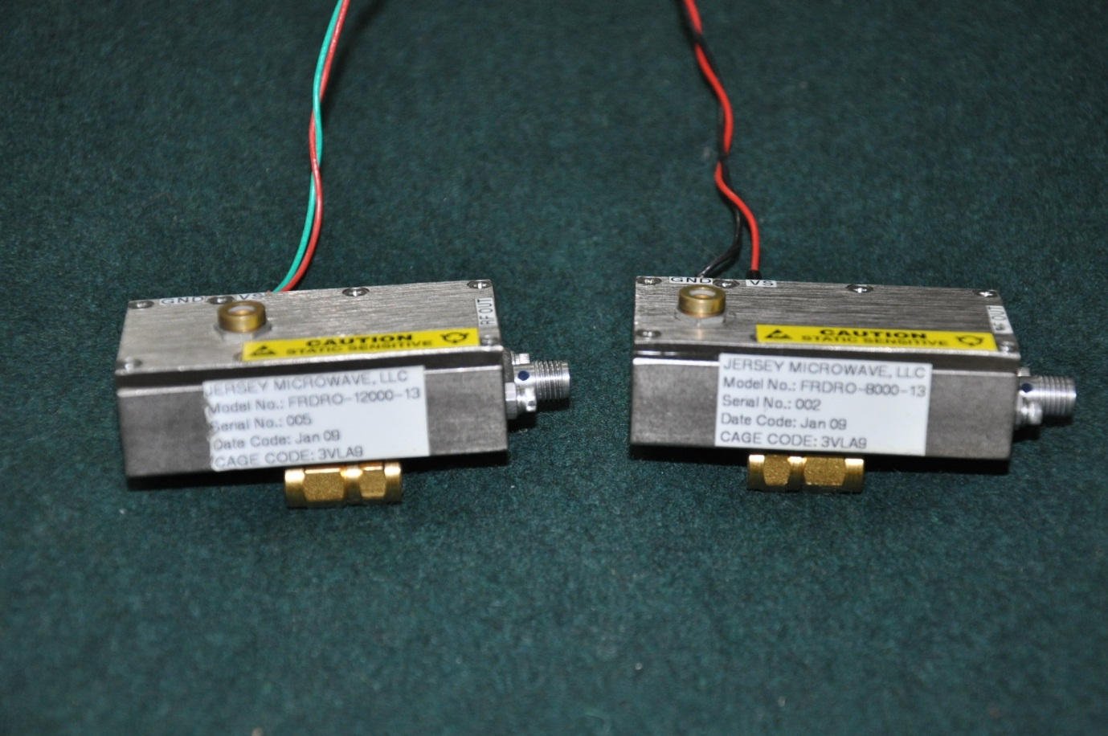

Figure 13.1: Dielectric Resonator Oscillator

DRO circuits utilize both silicon bipolar transistors and GaAs MESFET devices. All microwaveoscillators are designed by adding resonating elements (L, C or R) in various configurations to differentports of a transistor. These elements generate a negative resistance at a certain resonant frequency andset the device into oscillation. In the case of a DRO,the resonating element is the DR, which can be modelled electrically as an L, C, R network, shown in below figure.

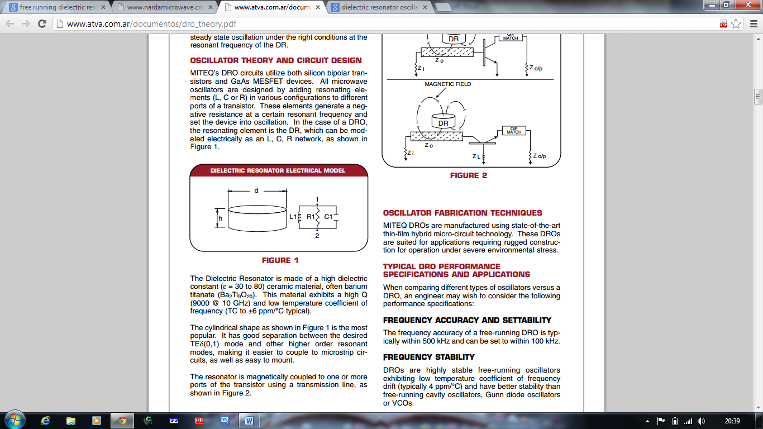

Figure 13.2: Dielectric Resonator Electric Model

The Dielectric Resonator is made of a high dielectricconstant (ε = 30 to 80) ceramicmaterial, often bariumtitanate (Ba2Ti9O20). This material exhibits a high Q(9000 @ 10GHz) and low temperature coefficient offrequency (TC to ±6 ppm/°C typical).The cylindrical shape as shown in Figure 1 is the mostpopular. It has good separation between the desiredTEδ(0,1) mode and other higher order resonantmodes, making it easier to couple to microstrip circuits, as well as easy to mount.The resonator is magnetically coupled to one or moreports of the transistor using a transmission line shown in below figure.

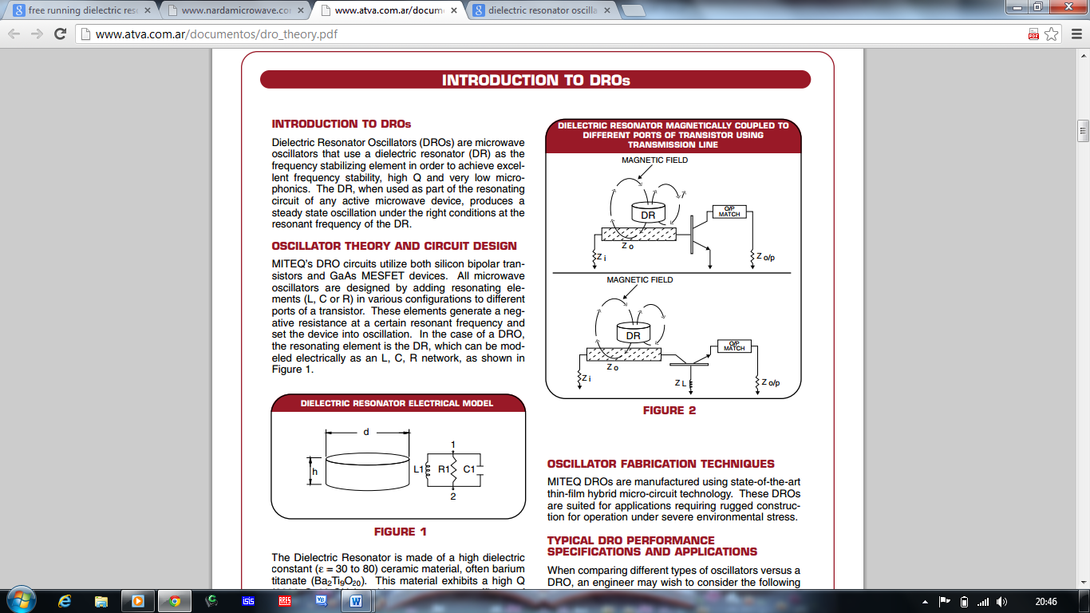

Figure 13.3: DR Magnetically coupled to Transistor using Transmission Line

* 1. **DRO PERFORMANCE SPECIFICATIONS**

DROs operate in the 3 to 18 GHz frequency rangeand typically use bipolar and FET active devices, depending on the requirement.

* + 1. **Output Power and DC Current**

A typical DRO source will provide a power out of +12 dBmor more at room temperature.This level will vary about±2dB over the specified temperature range with thepower decreasing with increasing temperature. The output power can be increased 5 to 10 dB by the addition ofan optional buffer amplifier. These units are regulated tooperate from +12 or +15 volts DC and the basic FET or bipolar transistor DRO will typically draw about 100 mA. Theamplifier option will draw an additional 100 mA.

* + 1. **Frequency Stability**

The frequency stability of the dielectric resonator oscillatoris primarily determined by the temperature coefficient ofthe dielectric resonator. This is approximately 5 ppm per°C which translates to ±5 MHz at 12 GHz over a temperature range of -54 to +85°C. This temperature coefficientwill degrade at higher frequency and also when a largerange of mechanical tuning is required. In certain instances the package can be designed so that its change indimension with temperature can accommodate change ofthe resonator frequency, thereby producing improvedtemperature performance. Varactor tuning can also beprovided for either frequency or phase locking.

* + 1. **Spurious Response**

A dielectric resonator oscillator is essentially free of spurious response. Typical specifications for non-harmonicspurious are on the order of 90 dBc which relates more tomeasurement system dynamic range than the actualpresence of spurious signal. Harmonics are typically inthe -10 to -20 dBc range and can be improved 20 to 30 dBby the addition of a miniature low pass filter.

* + 1. **Phase Noise**

DROs offer excellent phase noise performance. Figure below compares typical performance of DROs built with FET, bipolar and Gunn active elements. The level of performanceis in the -80 to -100 dBc per Hz range at a 10 kHz offset frequency around 6 GHz. Bipolar transistors offer superiorperformance; however, their utility is limited to about 6 GHzdue to power fall off athigher frequencies. Gunnoscillatorsoffer superior noise performance to FETs. However, thisimproved performance is normally offset by excessivepower drain and the FETs are often preferred. The other figure is an example of excellent phase noise performance in a high frequency.

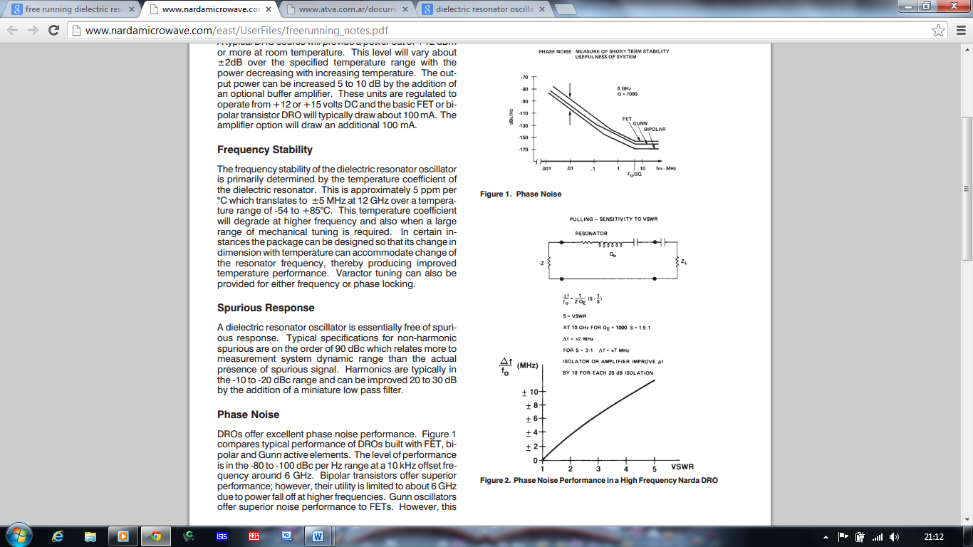

Figure 13.4: Phase Noise



Figure 13.5: Phase Noise at Higher Frequencies

* + 1. **Pushing**

Pushing is a sensitivity of the oscillator’s output frequencyto power supply variation. In DRO sources with integratedregulators, pushing effects are small and are typically wellbelow 100 kHz per volt.

* + 1. **Pulling**

Pulling is an oscillator’s sensitivity to VSWR changes. Unexpected reactive and resistive elements in the oscillatorload can tune an oscillator to a different frequency and, inextreme cases, result in the unit ceasing to oscillate.Pulling is reduced by isolating the oscillator from its load.Pulling is improved by a factor of 10 for each 20 dB of isolation added between the oscillator and its external load.

The three isolation techniques frequently employed are:

1. A buffer amplifier typically adds about 10 dB of isolation and 5 dB to 7 dB of gain. The disadvantages are increased cost and DC power requirements.
2. An isolator typically adds 18 dB of isolation with an insertion loss of 0.75 dB. Adding an isolator is usually less expensive than adding an amplifier and it doesn’t require the additional power. At lower frequencies, however, an isolator is usually much larger than an amplifier and may require a larger overall package size for the oscillator. Isolator use may also be limited at extreme temperatures.
3. Padding with resistors is the least expensive approach and normally doesn’t impact oscillator size. Pads of 2 to 6 dB, which add 4 to 12 dB of isolation, are practical. The major disadvantage is the reduced output power level of the oscillator.
   * 1. **Frequency accuracy and stability**

The frequency accuracy of a free-running DRO is typically within 500 kHz and can be set to within 100 kHz.

* + 1. **RF Power Output**

A DRO exhibits good power efficiency compared toother oscillators, such as a Gunn oscillator or VCO,due to lossless coupling of dielectric resonator element. It also has less power variation over temperature.

Dielectric Resonator Oscillators are used widely in today's electronic warfare, missile, radar and communication systems. They find use both in military and commercial applications. The DROs are characterized by low phase noise, compact size, frequency stability with temperature, ease of integration with other hybrid MIC circuitries, simple construction and the ability to withstand harsh environments. These characteristics make DROs a natural choice both for fundamental oscillators and as the sources for oscillators that are phase-locked to reference frequencies, such as crystal oscillators.

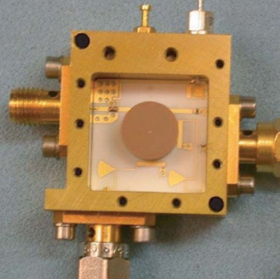

Figure 13.6: Internal of DRO

GND

+15V

ISOLATOR

DRO

12 GHz, 17dB

Spectrum Analyzer

Figure 13.7: Test Setup for DRO

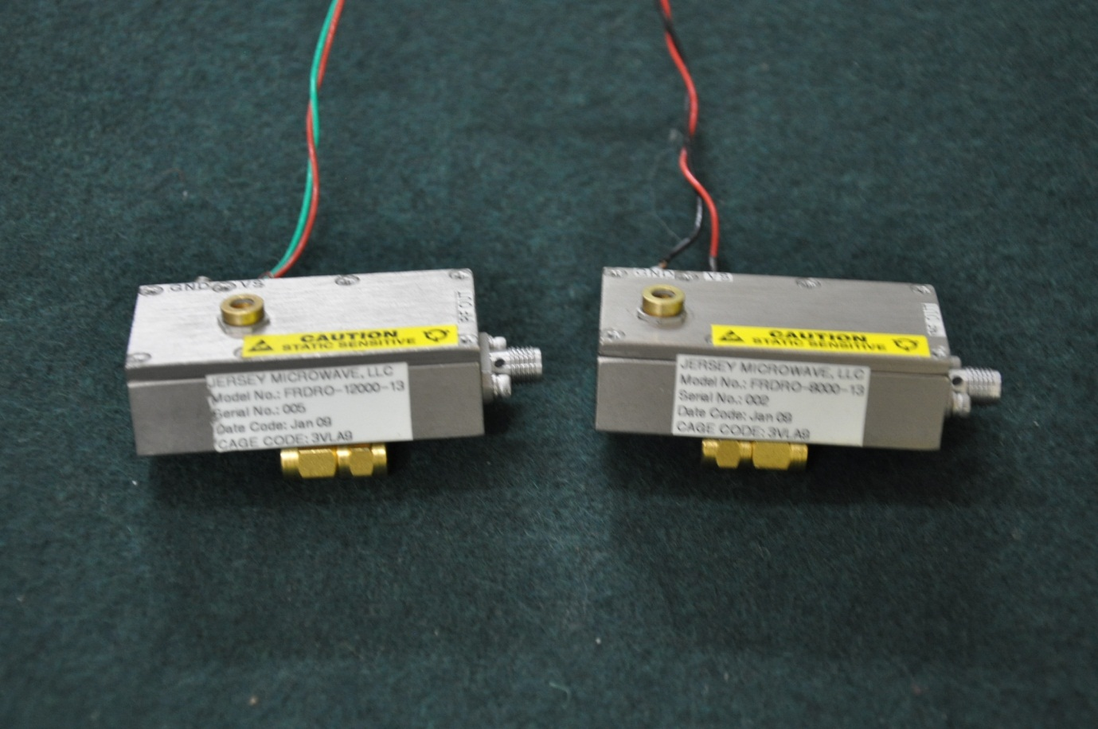

Figure 13.8: Dielectric Resonator Oscillator

**Specifications:**

* Frequency : 12 GHz
* Output Power : 17 dB
* Power Supply : +15V DC

1. **DIRECTIONAL COUPLER**

Directional couplers are RF passive devices used to couple a specific proportion of the power travelling in one transmission line out through another connection or port. Directional couplers find many applications in RF design, ranging from through line power sensors to transmitter automatic levels controls. As such they are particularly useful, enabling power levels to be sensed without making a direct connection to the transmission line carrying the power.

RF directional couplers can be implemented using a variety of techniques including strip line, coaxial feeder and lumped or discrete elements. They may also be contained within a variety of packages from blocks with RF connectors, or solder pins, or they may be contained on a substrate carrier, or they may be constructed as part of a larger unit containing other functions.

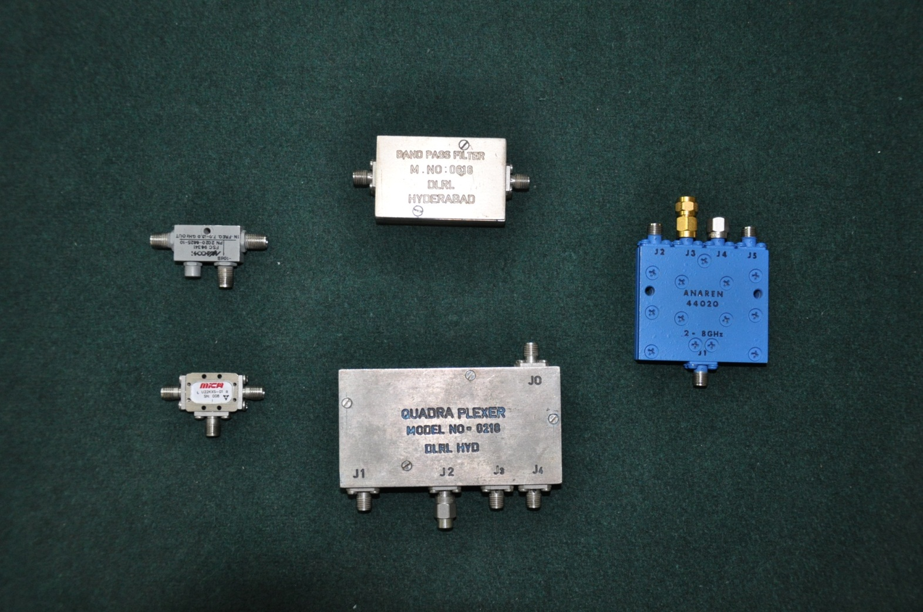

Figure 14.1: Directional Coupler

Directional couplers are most frequently constructed from two coupled transmission lines set close enough together such that energy passing through one is coupled to the other. This technique is favoured at the [microwave](http://en.wikipedia.org/wiki/Microwave) frequencies the devices are commonly employed with. However, [lumped](http://en.wikipedia.org/wiki/Lumped_element_model)component devices are also possible at lower frequencies. Also at microwave frequencies, particularly the higher bands, waveguide designs can be used. Many of these waveguide couplers correspond to one of the conducting transmission line designs, but there are also types that are unique to waveguide.

* 1. **Parameters**

Common properties desired for all directional couplers are wide operational [bandwidth](http://en.wikipedia.org/wiki/Bandwidth_(signal_processing)), high directivity, and a good [impedance match](http://en.wikipedia.org/wiki/Impedance_matching) at all ports when the other ports are terminated in matched loads. Some of these, and other, general characteristics are discussed below.

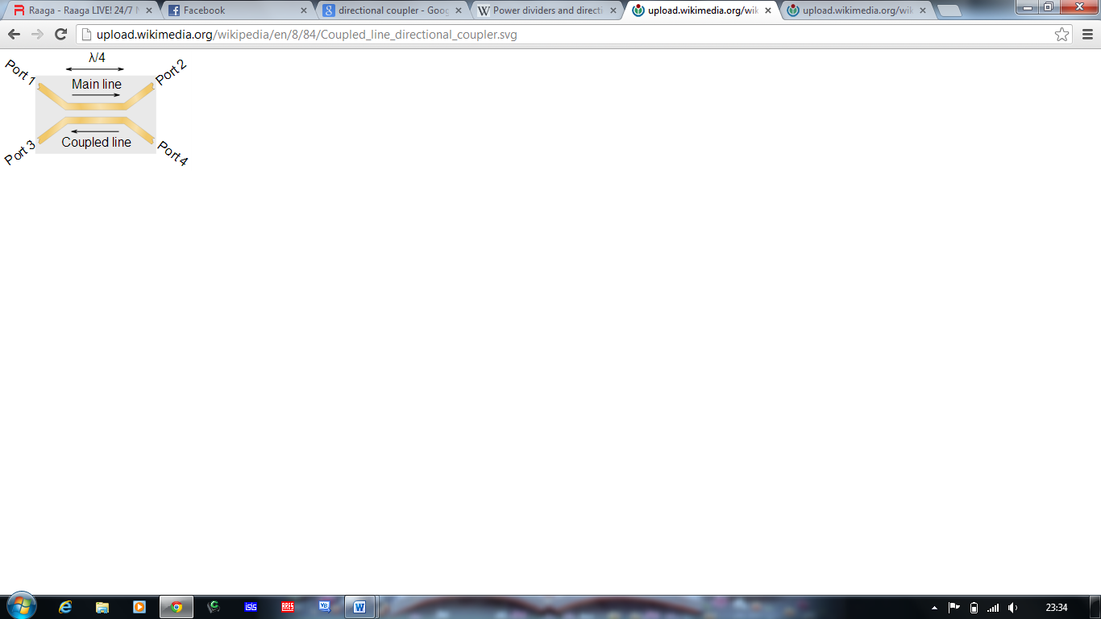

Figure 14.2: Strip Line Directional Coupler

### Coupling factor

### The coupling factor is defined as:

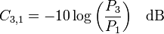

Where, P1 is the input power at port 1 and P3 is the output power from the coupled port. The coupling factor represents the primary property of a directional coupler. Coupling factor is a negative quantity, it cannot exceed 0 dB for a passive device, and in practice does not exceed−3 dB since more than this would result in more power output from the coupled port than power from the transmitted port – in effect their roles would be reversed. Although a negative quantity, the minus sign is frequently dropped (but still implied) in running text and diagrams and a few authorsgo so far as to define it as a *positive* quantity. Coupling is not constant, but varies with frequency. While different designs may reduce the variance. A perfectly flat coupler theoretically cannot be built. Directional couplers are specified in terms of the coupling accuracy at the frequency band centre.

* + 1. **Insertion Loss**

The main line [insertion loss](http://en.wikipedia.org/wiki/Insertion_loss) from port 1 to port 2 (P1 – P2) is:

Insertion loss:

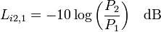

Part of this loss is due to some power going to the coupled port and is called [coupling loss](http://en.wikipedia.org/wiki/Coupling_loss) and is given by:

Coupling loss:

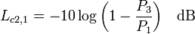

The insertion loss of an ideal directional coupler will consist entirely of the coupling loss. In a real directional coupler, however, the insertion loss consists of a combination of coupling loss, [dielectric](http://en.wikipedia.org/wiki/Dielectric) loss, conductor loss, and [VSWR](http://en.wikipedia.org/wiki/Standing_wave_ratio) loss. Depending on the frequency range, coupling loss becomes less significant above 15 dB coupling where the other losses constitute the majority of the total loss.

* + 1. **Isolation**

Isolation of a directional coupler can be defined as the difference in signal levels in dB between the input port and the isolated port when the two other ports are terminated by matched loads, or:

Isolation:

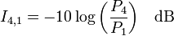

Isolation can also be defined between the two output ports. In this case, one of the output ports is used as the input; the other is considered the output port while the other two ports (input and isolated) are terminated by matched loads.

Consequently:

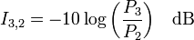

The isolation between the input and the isolated ports may be different from the isolation between the two output ports. For example, the isolation between ports 1 and 4 can be 30 dB while the isolation between ports 2 and 3 can be a different value such as 25 dB. Isolation can be estimated from the coupling plus [return loss](http://en.wikipedia.org/wiki/Return_loss). The isolation should be as high as possible. In actual couplers the isolated port is never completely isolated. Some [RF](http://en.wikipedia.org/wiki/Radio_frequency) power will always be present. [Waveguide](http://en.wikipedia.org/wiki/Waveguide) directional couplers will have the best isolation.

* + 1. **Directivity**

Directivity is directly related to isolation. It is defined as:

Directivity:



Where, P3 is the output power from the coupled port and P4 is the power output from the isolated port.The directivity should be as high as possible. The directivity is very high at the design frequency and is a more sensitive function of frequency because it depends on the cancellation of two wave components.

* + 1. **Amplitude Balance**

This terminology defines the power difference in dB between the two output ports of a 3 dB hybrid. In an ideal hybrid circuit, the difference should be 0 dB. However, in a practical device the amplitude balance is frequency dependent and departs from the ideal 0 dB difference.

* + 1. **Phase Balance**

The phase difference between the two output ports of a hybrid coupler should be 0°, 90°, or 180° depending on the type used. However, like amplitude balance, the phase difference is sensitive to the input frequency and typically will vary a few degrees.

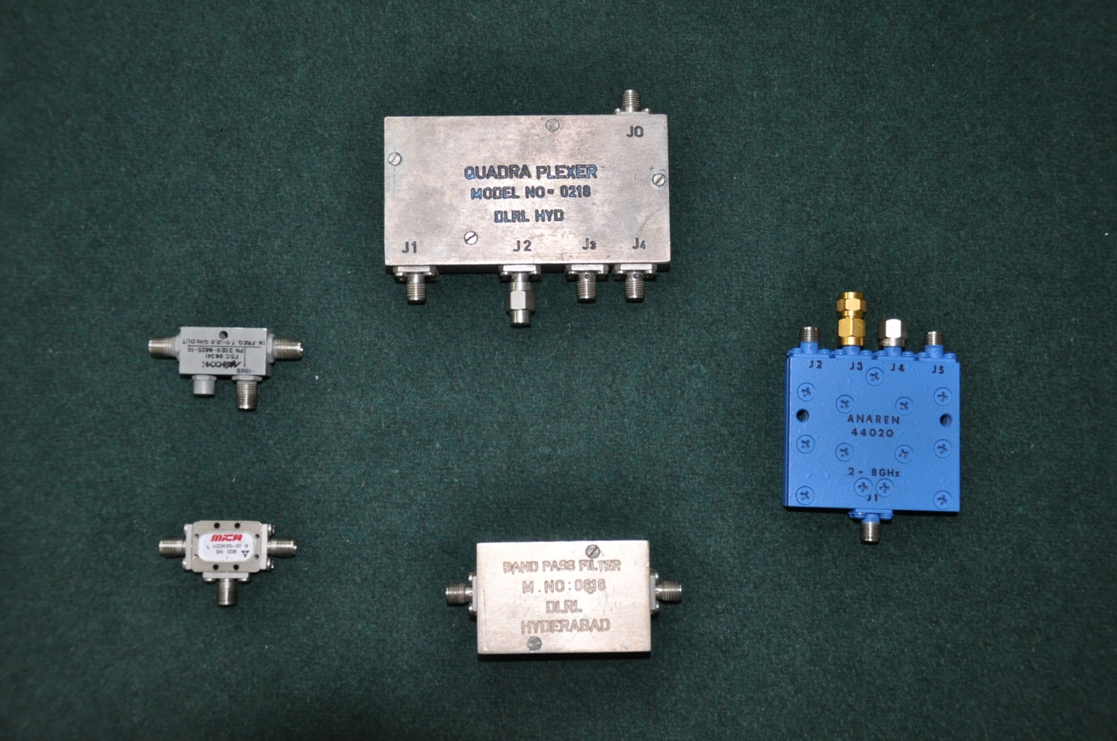

Figure 14.3: 10 dB Directional Coupler

**Specifications:**

* Frequency : 8 GHz to 18 GHz
* Insertion Loss : 1 dB
* Coupling : 20 dB
* Directivity : 16 dB
* VSWR : 1:4 max
* Peak Power : 24 mW
  1. **Experimental Aspects of Directional Coupler**

The Directional Coupler is a four port device. It has input port, output port, coupling port, and the direct port. In the analysis of the directional coupler the input port is given to the Signal Source and the output is taken from the output port and the coupling port and the power is seen in the spectrum analyser. The setup for the directional coupler is shown in the below figure.

MT

P1

DIRECTIONAL COUPLER

SIGNAL SOURCE

Spectrum Analyzer

P2

P3

P4

Spectrum Analyzer

Figure 14.4: Test setup for Directional Coupler

Input Power = 0 dBm

|  |  |  |
| --- | --- | --- |
| **Frequency (GHz)** | **Output Power (dBm)**  **(Output Port)** | **Output Power (dBm)**  **(Coupled Port)** |
| 8  9  10  11  12  13  14  15  16  17  18 | -3.01  -3.72  -3.90  -4.59  -3.9  -3.92  -3.86  -3.69  -3.72  -4.32  -3.92 | -12.7  -12.39  -11.4  -13.7  -12.01  -12.71  -12.05  -11.59  -12.95  -13.11  -14.71 |

Table 14.1: Test results for 10 dB Directional Coupler

1. **DETECTOR**

The very first RF transmissions were immediately followed be the need for RF power measurement. The easiest method for measuring power is the well-known peak detector, where a device usually a diode extracts the amplitude of the signal. In the case of amplitude modulation, the information of interest is directly accessible in the detected voltage, but when the measured parameter is the signal’s power it has to be translated into a more useful form.

* 1. **PARAMETERS OF DETECTOR**
     1. **Operating Frequency**

The RF signal frequency is probably the first parameter to consider when choosing a detector. The detector must be fast enough to extract the signal’s amplitude. It must also provide a constant response over the desired frequency range. Two internal parameters that are critical to achieve this requirement are the sensitivity (or gain) variation versus the frequency, and the input impedance matching.

* + 1. **Sensitivity and linearity**

Sensitivity is the detector’s ability to return usable information from a very low input signal. So the sensitivity definition is strongly linked with the processing capability of the system. If the detected signal is processed by an ADC having 1 mV step, the designer will check that the minimum signal level he wants to detect actually gives more than 1 mV at detector’s output. Higher sensitivity is better, but this cannot be achieved by simply increasing gain. That’s why detectors have been classified in two categories: linear and nonlinear.

* + 1. **Variations with environment**

Once implemented in a system, the detector must provide reliable information independent of the environment conditions. Integrated detectors usually have much higher power supply rejection performances than discrete solutions based on diodes. The detector is often supplied by a regulator which provides even more protection towards power variations. The variations with temperature are more difficult to manage at system level, because accurate temperature measurement is seldom available. So the stability versus temperature entirely relies on the detector itself.

* + 1. **Ease of Use**

The discrete diode detector is simple, but its optimization versus frequency and temperature over the full input power range, can consume a lot of time when the requirements are close to the performance limits. With an integrated detector, the optimization has been already done, and the function is fully characterized. The RF designer will probably confirm by his own measurements that the evaluation board gives the same results than the data sheet. He will then redo this measurement with the device in the application, and the work will be completed.

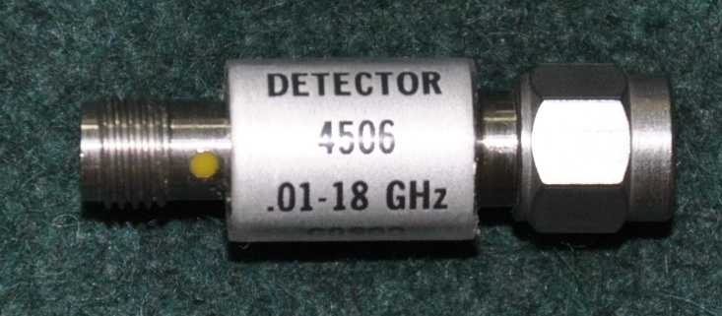

Figure 15.1: Detector

**Specifications**

* Frequency : 0.1-18GHz
* Hardness : +1dB
* Rise time : 10n sec
* RF Bypass capacitance : 12nf
* Maximum power : 100mW
* Operational temperature : -650C to +1000C

DETECTOR

SIGNAL SOURCE

Spectrum Analyzer

Figure 15.2: Setup for testing Detector

|  |  |  |
| --- | --- | --- |
| **S.No** | **Power Input (dBm)** | **Output (mV)** |
| 1 | -33 | -5.6 |
| 2 | -32 | 6.3 |
| 3 | -31 | 7.2 |
| 4 | -30 | 8.4 |
| 5 | -29 | 9.7 |
| 6 | -28 | 11.3 |
| 7 | -27 | 13.4 |
| 8 | -26 | 15.6 |
| 9 | -25 | 18.1 |
| 10 | -24 | 19.7 |
| 11 | -23 | 21.3 |
| 12 | -22 | 22.8 |
| 13 | -21 | 24.1 |
| 14 | -20 | 25.3 |
| 15 | -19 | 26.3 |
| 16 | -18 | 26.9 |
| 17 | -17 | 27.3 |
| 18 | -16 | 27.8 |
| 19 | -15 | 29.3 |

Table 15.1: Test result for Detector

* 1. **TESTING OF DETECTOR**

Input power: 0dBm,

Input frequency: 8GHz

Output pulse: Amp= -45.5mv, Frequency: 1 KHz, Time Period = 1ms.

CW SINE WAVE

8 GHz

SQUARE WAVE

MODULTED SQUARE WAVE

SIGNAL BEFORE DETECTION

SIGNAL AFTER DETECTION

Figure 15.3: Output pulse at 0dBm input power and 8 GHz frequency

Input power: 0dBm

Input frequency: 9GHz

Output Pulse:Amp = -52.375mv

CW SINE WAVE

9 GHz

SQUARE WAVE

MODULTED SQUARE WAVE

SIGNAL BEFORE DETECTION

SIGNAL AFTER DETECTION

Frequency: 1 KHz

Time Period = 1ms.

Figure 15.4: Output pulse at 0dBm input power and 9 GHz frequency

Input power: 0dBm

Input frequency: 9GHz

Output Pulse:Amp = -52.375mv, Frequency: 1 KHz, time Period = 1ms.

CW SINE WAVE

8 GHz

SQUARE WAVE

MODULTED SQUARE WAVE

SIGNAL BEFORE DETECTION

SIGNAL AFTER DETECTION

Figure 15.5: Output pulse at 0dBm input power and 9 GHz frequency

1. **SPECTRUM ANALYZER**

A spectrum analyzer measures the magnitude of an input signal versus frequency within the full frequency range of the instrument. The spectrum analyser calibrated graphical display on its CRT with frequency on the horizontal axis and amplitude on the vertical axis .Therefore as the scan moves along the horizontal axis, the display shows the level of any signals at that particular frequency.

The primary use is to measure the power of the spectrum of known and unknown signals. It can display signals composed of more than one frequency(complex signals) .A spectrum analyzer interface is a device that connects to a wireless receiver or a personal computer to allow visual detection and analysis of electromagnetic signals over a defined band of frequencies.

Spectrum analyser can also discriminate between the components of the signal and measures the power level at each one. Spectrum analyzers are widely used to measure the frequency, power, distortion, harmonics, bandwidth,and other spectral components of a signal can be observed that are not easily detectable in time domain waveform.

Spectrum analysers are also known as Real Time Analyser (RTA) or Real Time Spectrum Analyser (RTSA), as these analysers display the complete spectrum of the signal frequencies simultaneously on the same screen.

The following are some of the applications of the Spectrum Analyser

They are used for observing purity of a signal.

• They are used for analyzing modulated signals.

• They are used for studying harmonic components of a signal.

• They are used for finding intermodulation content.

• They are used in the measurement of long and short term stability such as noisebands of an oscillator.

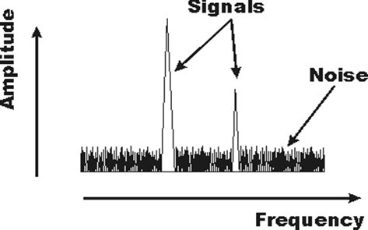

Figure 16.1: General format of the display on a spectrum analyzer

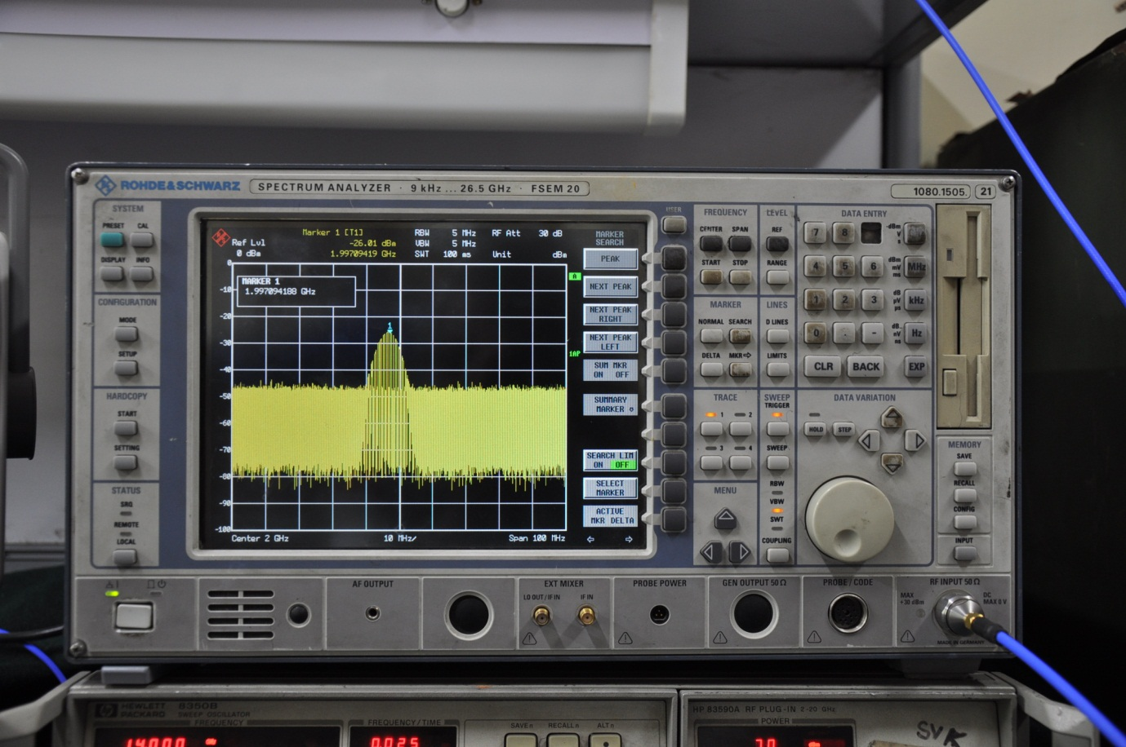

Figure 16.2: Pulse Modulated Signal in Spectrum Analyzer

**Specifications**

Frequency Range: 9KHz -26.5GHz

Manufacturer :Rhode &Schwarz

1. **DIGITAL STORAGE OSCILLOSCOPE**

A digital storage oscilloscope is an oscilloscope which stores and analyses the signal digitally rather than using analogue techniques. It is a special purpose oscilloscope, which provides digital readout of the information such as voltage,time etc. In this type of oscilloscope,the waveform to be stored is digitized,stored in a digital memory and retrieved for display on the storage Oscilloscope.

It is now the most common type of oscilloscope in use because of the advanced trigger, storage, display and measurement features which it typically provides.

The input analogue signal is sampled and then converted into a digital record of the amplitude of the signal at each sample time. The sampling frequency should be not less than the Nyquist rate to avoid aliasing. These digital values are then turned back into an analogue signal for display on a cathode ray tube (CRT), or transformed as needed for the various possible types of output—liquid crystal display, chart recorder, plotter or network interface.

The principal advantage over analog storage is that the stored traces are as bright, as sharply defined, and written as quickly as non-stored traces. Traces can be stored indefinitely or written out to some external data storage device and reloaded. This allows, for example, comparison of an acquired trace from a system under test with a standard trace acquired from a known-good system. Many models can display the waveform prior to the trigger signal.

Digital oscilloscopes usually analyse waveforms and provide numerical values as well as visual displays. These values typically include averages, maxima and minima, root mean square (RMS) and frequencies. They may be used to capture transient signals when operated in a single sweep mode, without the brightness and writing speed limitations of an analog storage oscilloscope.

The displayed trace can be manipulated after acquisition; a portion of the display can be magnified to make fine detail more visible, or a long trace can be examined in a single display to identify areas of interest. Many instruments allow a stored trace to be annotated by the user.

Many digital oscilloscopes use flat panel displays similar to those made in high volumes for computers and television displays.

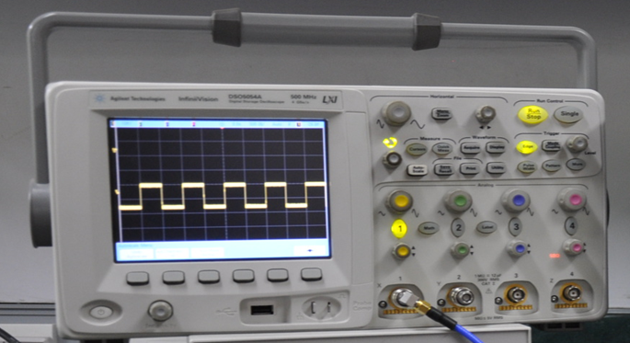

Figure 17.1: Detected Pulse in Digital Storage Oscilloscope

**Specifications**

Frequency Range:500MHz

Manufacturer :Agilent Technologies

1. **SWEEP OSCILLATOR**

Generally it is a piece of test equipment that is able to sweep a CW signal across a specific band, either in a frequency modulation mode. A good sweep oscillator uses a phase-locked loop to ensure that the signal frequency is accurate and stable. Such a device is often called a "synthesizer".

Sweep Oscillator is a powerful general-purpose source for swept microwave measurements, CW signal generations and automatic testing and provides a frequency range of 2- 20 GHz. It includes many productivity features, such as five independent, continuously variable markers, a marker sweep function, and save/recall registers that provide quick access to nine complete front panel settings.

• Broadband frequency coverage

• High output power

• Low harmonics

• Five frequency markers

* 1. **PARAMETERS**
     1. **Frequency Accuracy**

Expressed in parts per million, this tells you the worst-case error you can expect when you command your oscillator to a specific frequency. The 10 cent crystal in a cheap digital watch is accurate to 23 ppm if it loses one minute per month.

* + 1. **Stability**

This is a measure of the frequency drift over time. As increasing number of users crowd the electromagnetic spectrum, the need for frequency stability becomes greater every year.

* + 1. **Warm-uptime**

Since many oscillators are so temperature dependent for accuracy often ovens are used to stay at a fixed temperature, some equipment that uses oscillators has a lengthy warm-up time. For example, it may take overnight for a network analyzer to stabilize after you plugs it in, and this is the fault of the sweep oscillator.

* + 1. **Turn-on power**

Especially with an oven-stabilized oscillator, the dissipation when you first throw the switch can be a lot higher than the

* + 1. **Harmonic signals**

A harmonic frequency is any multiple of the intended frequency. A ten GHz oscillator may have 20 GHz, 30 GHz, 40 GHz... output signals at low power levels; these are the second, third and fourth harmonic.

* + 1. **Sub harmonic signals**

Subharmonic frequencies are signals that occur at 1/2, 1/3, 1/4... the intended signal.

* + 1. **Spurious signals**

Spurious signals are seemingly not related to the fundamental output frequency, and can be either below or above it.

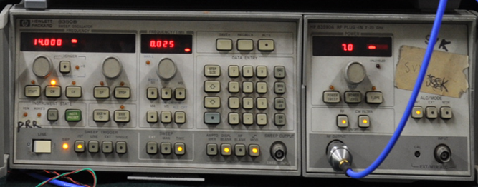

Figure 18.1:Sweep Oscillator

**Specifications**

Frequency Range:2-20GHz

Manufacturer :Hewlett Packard

1. **HORN ANTENNA**

A horn antenna or microwave horn is an antenna that consists of a flaring metal waveguide shaped like a horn to direct radio waves in a beam. Horns are widely used as antennas at UHF and microwave frequencies, above 300 MHz. They are used as feeders (called feed horns) for larger antenna structures such as parabolic antennas, as standard calibration antennas to measure the gain of other antennas, and as directive antennas for such devices as radar guns, automatic door openers, and microwave radiometers. Their advantages are moderate directivity (gain), low SWR, broad bandwidth, and simple construction and adjustment.

An advantage of horn antennas is that since they have no resonant elements, they can operate over a wide range of frequencies, a wide bandwidth. The usable bandwidth of horn antennas is typically of the order of 10:1, and can be up to 20:1 (for example allowing it to operate from 1 GHz to 20 GHz). The input impedance is slowly-varying over this wide frequency range, allowing low VSWR over the bandwidth. The gain of horn antennas ranges up to 25 dBi, with 10 - 20 dBi being typical.

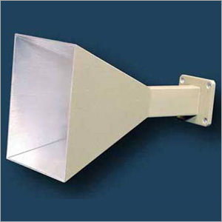

Figure 19.1: Horn Antenna

A horn antenna is used to transmit radio waves from a waveguide (a metal pipe used to carry radio waves) out into space, or collect radio waves into a waveguide for reception. It typically consists of a short length of rectangular or cylindrical metal tube (the waveguide), closed at one end, flaring into an open-ended conical or pyramidal shaped horn on the other end. The radio waves are usually introduced into the waveguide by a coaxial cable attached to the side, with the central conductor projecting into the waveguide to form a quarter-wave monopole antenna. The waves then radiate out the horn end in a narrow beam. However in some equipment the radio waves are conducted between the transmitter or receiver and the antenna by a waveguide, and in this case the horn is just attached to the end of the waveguide.

* 1. **OPTIMUM HORN**

For a given frequency and horn length, there is some flare angle that gives minimumreflection and maximum gain. The internal reflections in straight-sided horns come from the two locations along the wave path where the impedance changes abruptly; the mouth or aperture of the horn, and the throat where the sides begin to flare out. The amount of reflection at these two sites varies with the flare angle of the horn (the angle the sides make with the axis). In narrow horns with small flare angles most of the reflection occurs at the mouth of the horn. The gain of the antenna is low because the small mouth approximates an open-ended waveguide. As the angle is increased, the reflection at the mouth decreases rapidly and the antenna's gain increases. In contrast, in wide horns with flare angles approaching 90° most of the reflection is at the throat. The horn's gain is again low because the throat approximates an open-ended waveguide. As the angle is decreased, the amount of reflection at this site drops, and the horn's gain again increases.

This discussion shows that there is some flare angle between 0° and 90° which gives maximum gain and minimum reflection. This is called the optimum horn. Most practical horn antennas are designed as optimum horns. In a pyramidal horn, the dimensions that give an optimum horn are:



For a conical horn, the dimensions that give an optimum horn are:



Where,

aE is the width of the aperture in the E-field direction

aH is the width of the aperture in the H-field direction

LE is the slant length of the side in the E-field direction

LH is the slant length of the side in the H-field direction.

d is the diameter of the cylindrical horn aperture

L is the slant length of the cone from the apex.

λ is the wavelength

An optimum horn does not give maximum gain for a given aperture size; this is achieved by a very long horn (an aperture limited horn). It gives the maximum gain for a given horn length.

* 1. **GAIN**

Horns have very little loss, so the directivity of a horn is roughly equal to its gain. The gain G of a pyramidal horn antenna (the ratio of the radiated power intensity along its beam axis to the intensity of an isotropic antenna with the same input power) is:

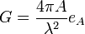

For conical horns, the gain is:

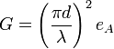

Where,

A is the area of the aperture,

d is the aperture diameter of a conical horn

λ is the wavelength,

eA is a dimensionless parameter between 0 and 1 called the aperture efficiency,

The aperture efficiency ranges from 0.4 to 0.8 in practical horn antennas. For optimum pyramidal horns, eA = 0.511., while for optimum conical horns eA = 0.522. So an approximate figure of 0.5 is often used. The aperture efficiency increases with the length of the horn, and for aperture-limited horns is approximately unity.

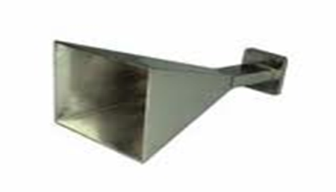

Figure 19.2: Horn Antenna (Gain 14dB)

**Specifications**

**•** Type : Pyramidal

• Frequency : 8-18 GHz

• Gain of Antenna : 16dB

• Antenna Beam width : 8

• O/P power : -21.8dB

• Effective power : -5.8dB

1. **KU BAND MICROWAVE RECEIVER**

The Ku Band Microwave Receiver works on the Principle of Super Heterodyne. Heterodyne means mixing of signals. This is used to up convert or down convert the frequencies. This is a front end receiver. The receiver will receive the modulated signal and demodulate the signals and with a particular gain and eliminating the noise it gives the perfect signal to the processing unit.

* 1. **BLOCK DIAGRAM OF Ku BAND MW RECEIVER**

ANTENNA

Attenuator

(-6dB)

MT

ISOLATOR

GND

+15V

DRO

12 GHz,17dB

MIXER

RF

IF

LO

MT

DETECTOR

TRIPLEXER

Spectrum Analyzer

SWITCH

(SP2T)

LOW NOISE AMPLIFIER

GND

+15V

GND

+15V

DRO

12 GHz,17dB

GND

+15V

CONTROL SIGNALS

POWER DIVIDER

CRO

2GHz – 8GHz

8GHz – 14GHz

14GHz – 20GHz

Attenuator

(-6dB)

Attenuator

(-6dB)

Figure 20.1: Block Diagram of Ku Band Microwave Receiver

The above block diagram represents the receiver front end, it works mainly on the principle of super heterodyne.

* 1. **DESIGNING OF MICROWAVE FRONT END RECEIVER**

The Receiver is designed based on the principle of the super heterodyne Receiver. This is widely used on communication and Electronic warfare (EW) systems. Uses down conversion principle to improve the sensitivity. The sensitivity improvement up to -90dBm or better is achieved by increasing the signal amplification gain and reducing the noise band width.

* 1. **SPECIFICATIONS**
* RF (input frequency range) : 8 GHz to 18 GHz
* IF (output frequency range) : 2 GHz to 6 GHz
* Number of Down Conversions : one
* Gain : 25 dB
* Dynamic range: 40 dB
* Noise Figure : 8 dB
* Internally generated

Spurious/Harmonics in Band : -50 dBC

* TSS : -56 dBm
* VSWR : 2.5:1

**Gain:**

It is the difference between the output power and input power of the receiver (in dB) .

RF input Power= -15dB

IF output Power= -40dB

Gain= |-40 –(-15)| = 25 dB

The receiver gain is mainly used for the purpose of feeding the processing unit that comes after the front end receiver the power must be sufficient because of the processing unit may take more power.

**Dynamic range:**

It is the range of the input signal from minimum to maximum, the receiver will respond as expected i.e., from -25 to -65dB power.

**Minimum detectable signal:**

It is the minimum signal which the receiver can detect.

MDS= -114 dBm + 10 logBW(in MHz) + NF

As we are considering the frequencies from 8-18 GHz, the Band Width is 10GHz.

10 GHz=10,000 MHz

Noise Figure =8dB

MDS=-114+10log(10,000 MHz)+8 = -66dB

**Noise Figure:**

It is the measure of noise produced by a particular receiver compared with the noise of an ideal receiver.

**Tangential Signal Sensitivity (TSS):**

Tangential signal is defined as the pulse whose bottom level coincides with the top level of the noise on either side of the pulse. The corresponding signal-to-noise ratio (SNR) depends on many system factors, normally the SNR of 8 dB is generally accepted at the specified bandwidth.

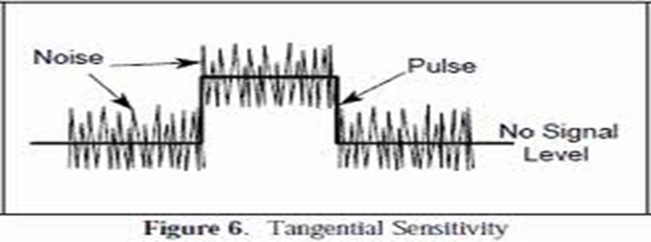

Figure 20.2: TSS (Tangential Signal Sensitivity)

**VSWR:**

VSWR stands for Voltage Standing Wave Ratio. It is the ratio of the maximum/minimum values of standing wave pattern along a transmission line to which a load is connected. VSWR value ranges from 1 (matched load) to infinity for a short or an open load. The VSWR value 2.5:1 denotes maximum standing wave amplitude that is 2.5 times greater than the minimum standing wave value.

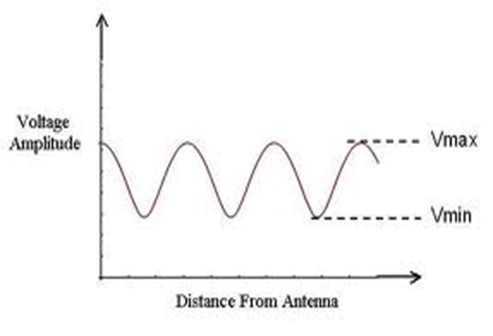

Figure 20.3: VSWR

* 1. **DESIGN EQUATIONS**

The design equations are used to design the receiver. By calculating these equations we can achieve the design of a receiver theoretically.

1. **Minimum Detectable Signal:**

This is also called as Minimum Discernable Signal (MDS). This can be defined as the minimum signal that can be detected by the receiver.

$$MDS= -114+10\log\left[B_{r}+N_{F}+SNR\right]$$

1. **Tangential Signal Sensitivity:**

Tangential signal is defined as the pulse whose bottom level coincides with the top level of the noise on either side of the pulse.

$$TSS=-114+10\log\left[2.5\sqrt{2B_{r}B_{v}-{B_{v}}^{2}}+6.31B_{v}\right]+NF$$

Where,

$B_{r}$ (MHz) = RF Bandwidth i.e., Final IF Bandwidth (4000 MHz)

$B_{v}$ (MHz) = Video Bandwidth i.e., 10 MHz, 20 MHz, 40 MHz

$NF$ (dB) = 8 dB

1. **Noise Power:**

Noise Power = KT $B_{n}$

Where, $B_{n}$ = Bandwidth over which Noise is measured.

K = ${1.38 × 10}^{-23}J/{o_{C}}$ (Boltzmann Constant)

$$Noise Power=-114{dBm}/{MHz}$$

1. **Sensitivity:**

The Sensitivity is defined as the receiver capability of receiving the signal.

$$Sensitivity=-110 \left(10\log\left(BW\right)+Noise Figure\right)$$

1. **Path Loss:**

The signal is transmitted from the Transmitter and the loss is present in the path where the signal travels. So, there may not be total transmission of the power, there will be some of the losses in the path during its travel.

$$Path Loss=-\left[32+20\log\left(F*D\right)\right]$$

By above all the considerations we can design a receiver and can choose the component as we required. The important thing while designing a receiver is that there must more sensitivity and less noise with a high gain.

* 1. **RECEIVER OPERATION**

This receiver works on the principle of Super Heterodyne. The setup of the receiver is shown below. The transmitted signal is received through the antenna of the receiver. The antenna type used in here is the Horn antenna due to its high gain and the design is simple with less cost. The antenna is connected to the receiver starting component i.e., to the isolator, this is mainly used to allow the signals in only one direction and blocks in the other direction, this device is very helpful in blocking the unwanted signal back to the antenna that are observed from the amplifier. The isolator is connected to the amplifier, the Amplifier is the Low Noise Amplifier (LNA). The LNA is used because it eliminates the noise in the first stage of the amplification. The dynamic range of the receiver can be set by using the amplifier gain.

The LNA output is connected to an attenuator, the attenuator is used to decrease the signal strength without any loss or change in the signal. The next stage of the receiver is the Triplexer, the triplexer is used to separate the bands by using the band pass filters, and this separates a band of frequencies in to three bands. According to our requirement we can select the band and can connect the mixer to triplexer.

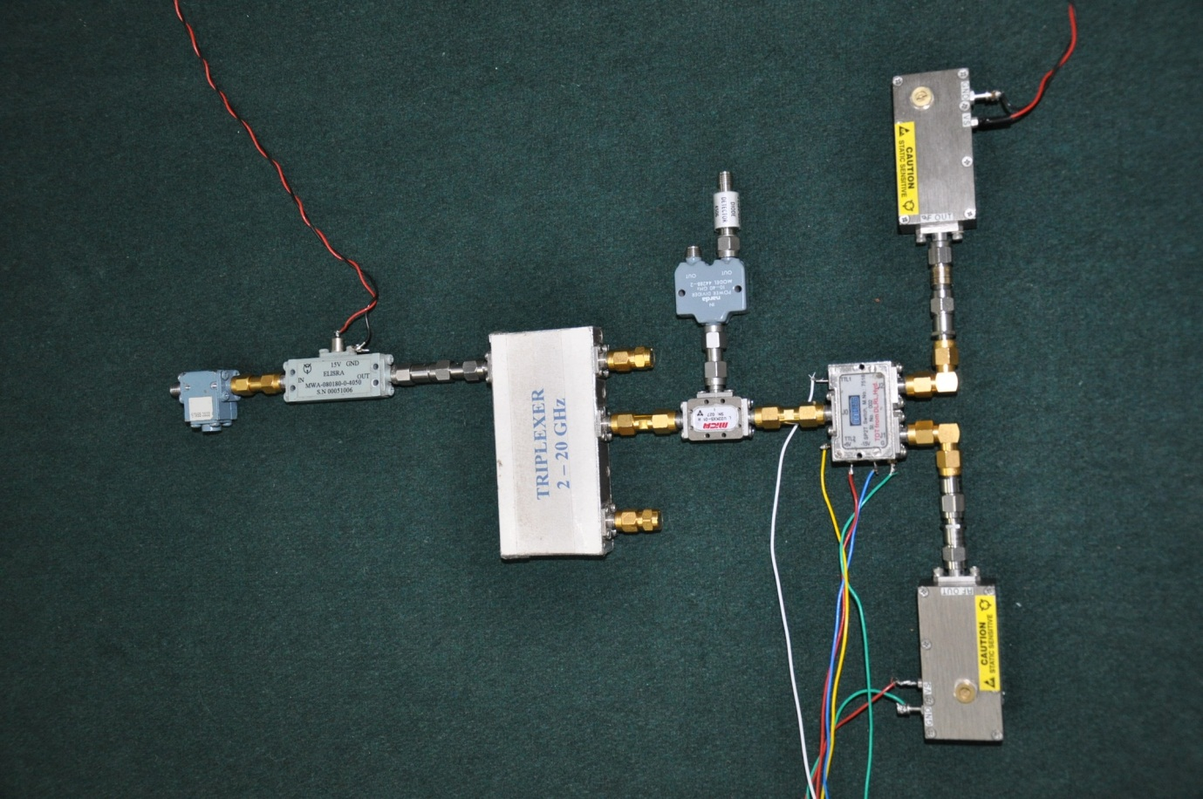

Figure 20.4: Setup of Ku Band Microwave Receiver

The Triplexer output is given to the RF input of the mixer and the LO of the mixer is connected with the two DRO’s by using a switch and a particular DRO can be selected by using the Control signals of the switch, i.e., either we can select the 8GHz DRO or the 12GHz DRO. The mixer combines the two signals and down converts to an Intermediate Frequency (IF) i.e., 4GHz. And the IF is given to the Power Divider, this divides the power equally in to its ports.one port is given to the Spectrum analyzer and the other port is given to the Detector and to CRO. The antenna provides the gain of +14dB which is very useful for the receiver for the entire process.

From the above given equations we can be able to set the sensitivity of the receiver, Noise Power, TSS, MDS. The spectrum analyzer readings of the receiver and the detector output and the CRO is shown in the below figures.

The input to the receiver is the pulse modulated sine wave carrier. With a power starting from -25dB to -65dB.



Figure 20.5: Detected Modulated Pulse in the Spectrum Analyzer

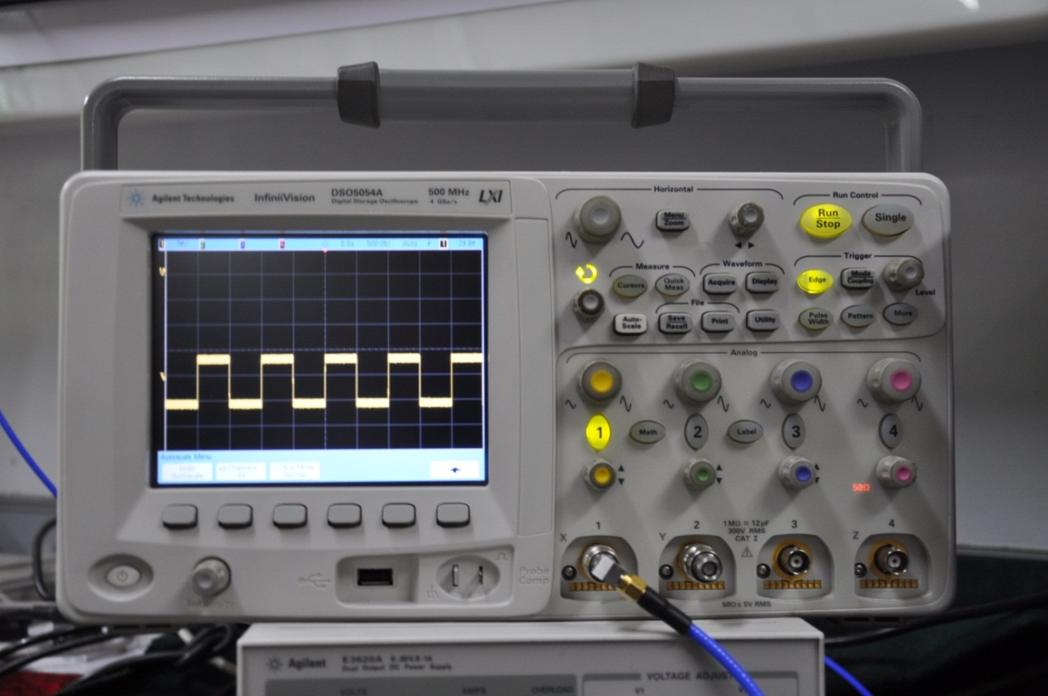

Figure 20.6: Output of Detector in CRO (Transmitted Pulse)

* 1. **SIMULATION IN GENESYS**

According to the above specifications of the Receiver, the receiver is simulated in Genesys software which is one of the powerful tools for simulating the entire system with separate blocks.

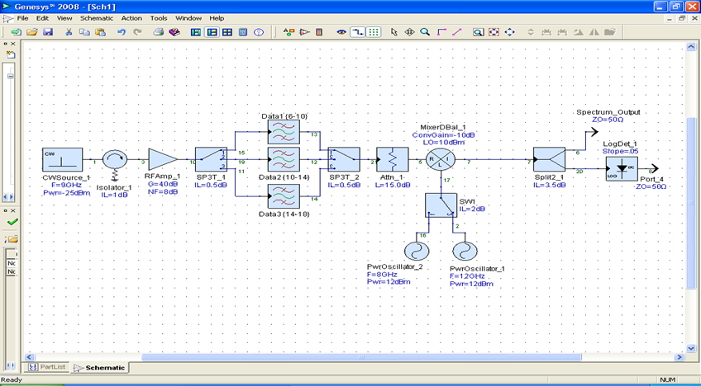

Figure 20.7: Block Diagram of Receiver in Genesys Software

The output of the simulation is shown in the below figures.

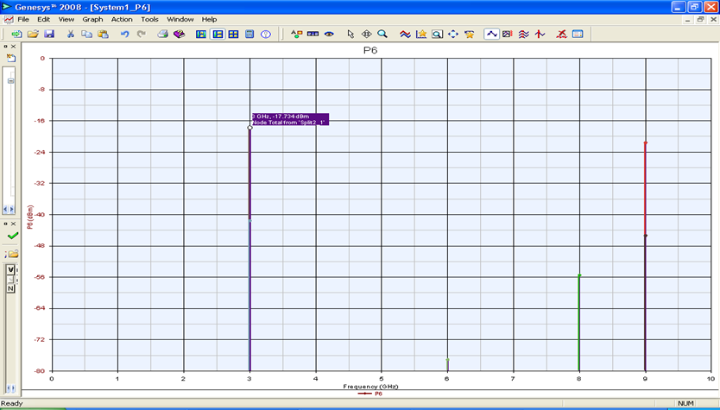

Figure 20.8: IF Output

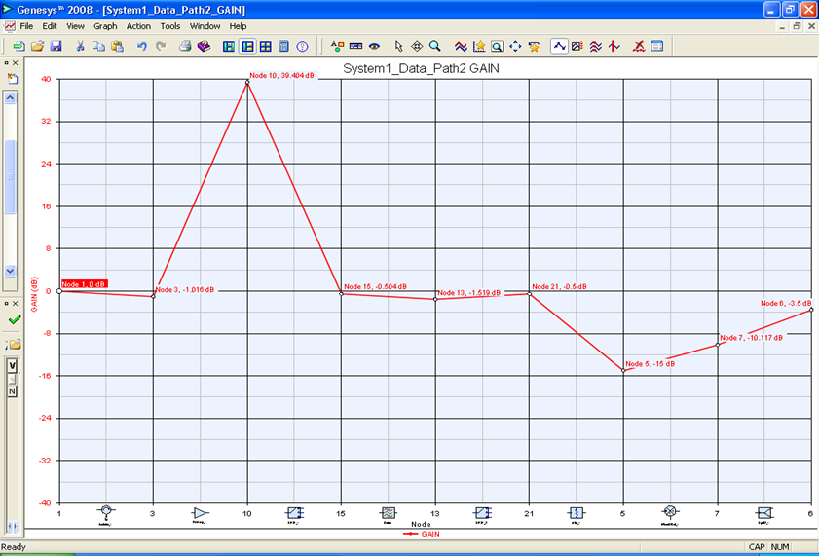

Figure 20.9: Gain

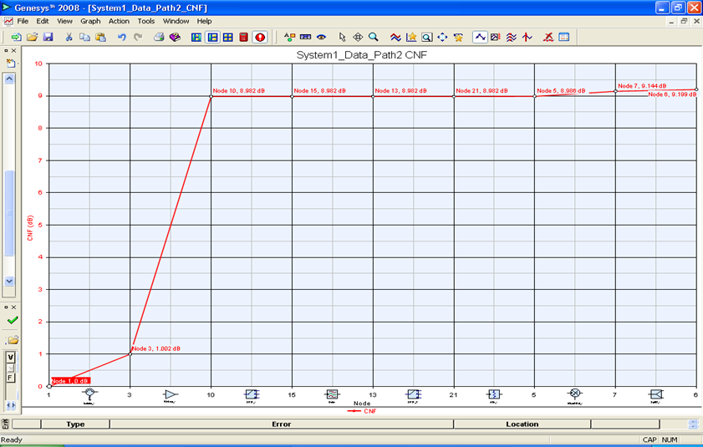

Figure 20.10: Noise Figure

1. **POWER BUDGET**

The power budget indicates the total power at each component of the microwave receiver.

* 1. **CALCULATION OF POWER BUDGET**

Attenuator

(-6dB)

MT

ISOLATOR

(-1dB)

GND

+15V

DRO

12 GHz,17dB

MIXER

(-10dB)

RF

IF

LO

MT

DETECTOR

TRIPLEXER

(-1dB)

Spectrum Analyzer

SWITCH

(SP2T)

LOW NOISE AMPLIFIER

(+40 dB)

GND

+15V

GND

+15V

DRO

12 GHz,17dB

GND

+15V

CONTROL SIGNALS

POWER DIVIDER

(-6dB)

CRO

2GHz – 8GHz

8GHz – 14GHz

14GHz – 20GHz

Attenuator

(-6dB)

Attenuator

(-6dB)

Figure 21.1: Receiver Block Diagram for Calculation of Power Budget

* + 1. **Loss at each stage**
* Power input : -60dB
* Cable loss : -5dB
* Antenna Gain : +14dB
* Path Loss (1mt) between Antennas : -44dB
* Amplifier : +35dB
* Attenuator : -6dB
* Triplexer Isolation loss : -1dB
* Switch Isolation loss : -2dB
* Mixer : -10dB
* Directional coupler : -10dB
* Power divider : -6dB
* Output power : -33dB
* Gain: Output Power- Input Power= -33-(-60) =27 dB

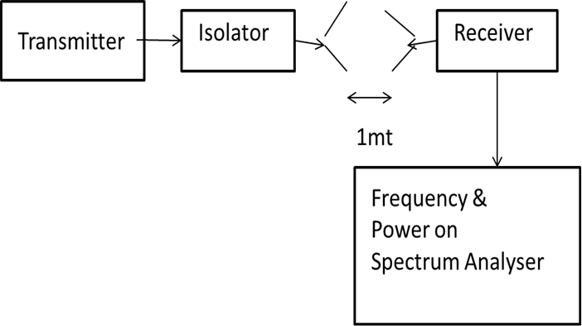

Figure 21.2: Transmitter and Receiver Setup

* + 1. **Evaluation of a Microwave Receiver**

At Frequency (F) = 12 GHz,

Distance between Transmitting Antenna sand Receiving Antenna (D)=1 mt

Path Loss= -[32+20 log (F.D)]

= -[32+20 log (12000)(1*0.001)]

**=-**44

* + 1. **Power Budget**

Power Budget = **(-**25dBm -1 dBm +14 dBm -32 dBm +14 dBm -3 dBm +35 dB -10 dBm -10 dBm -1 dBm -10 dBm)= -29dBm

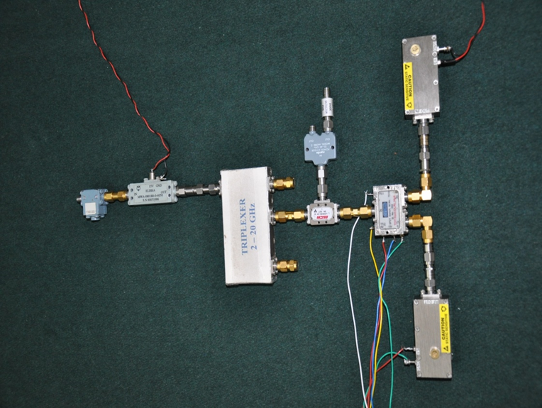

Figure 21.3: Receiver Setup

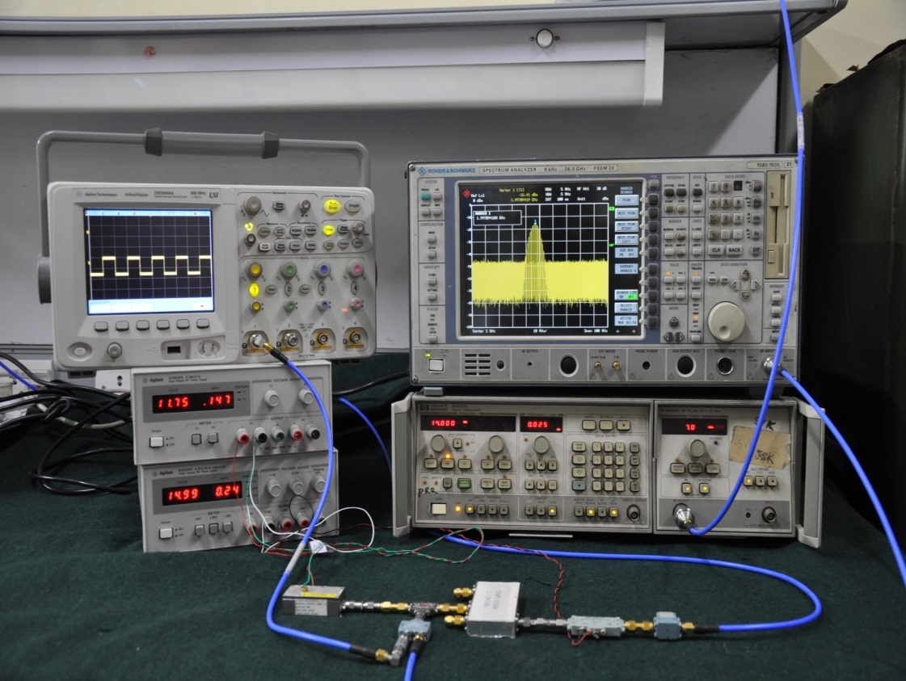

Figure 21.4: Test setup of Entire Ku Band Microwave Receiver

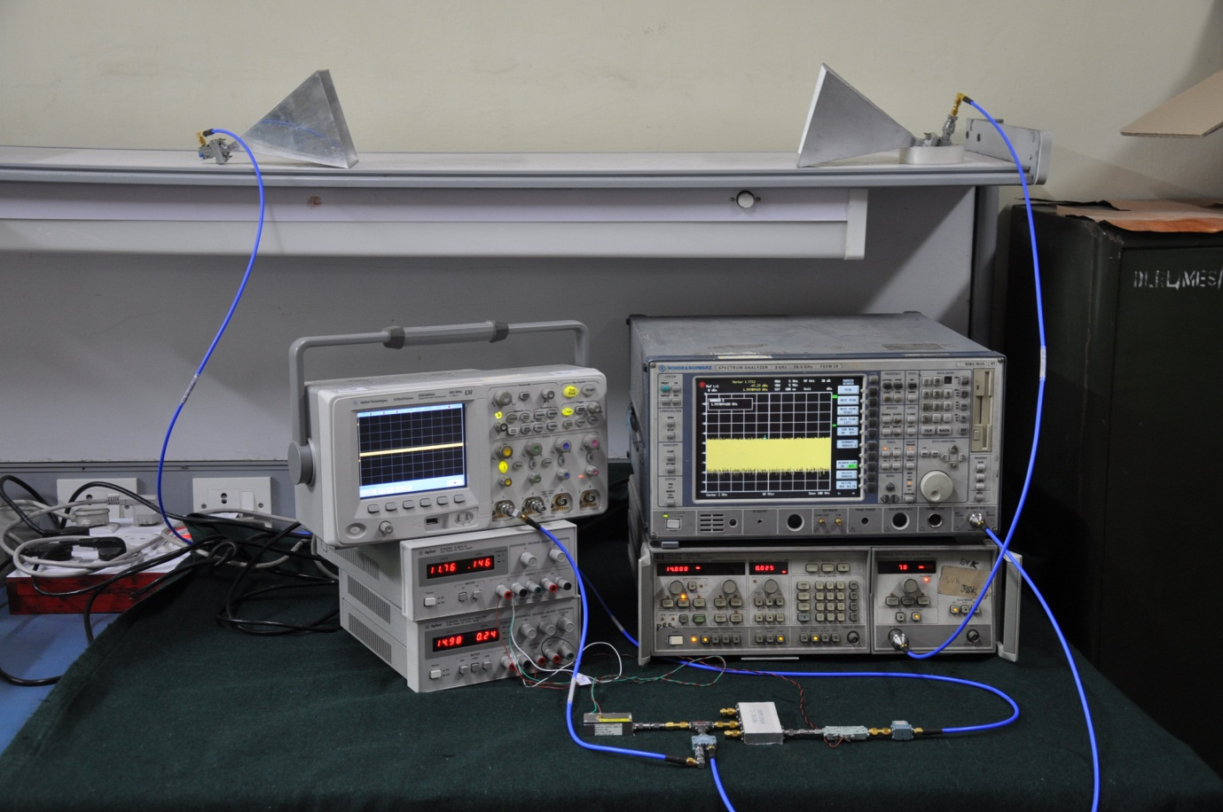

Figure 21.5: Test setup for Ku Band MW Receiver with Tx and Rx Antenna’s

1. **CONCLUSION AND FUTURE SCOPE**
   1. **CONCLUSION**

The Microwave front end Receiver in Ku-band is Designed and Simulated using Genesys-2008 Software. Each Microwave Receiver component is practically tested and analysed. All these tested components are integrated forming a Receiver and its performance is evaluated**.**

* 1. **FUTURE SCOPE**

Microwave receivers which are operated in the frequency of 6-18 GHz have many applications in the fields of communication, RADAR, Electronic warfare, Satellite communication etc. Understanding the use of receivers in radar and communications systems provides a system perspective and an understanding of how the receiver affects the system performance and the receiver stability required by the system.

The common carrier microwave communication system in the world are now operate in the frequency regions of 2GHz,4GHz, 8GHz and 11GHz for multi telephone channels, television relay and data transmission.

Communications terminals can operate within sight of each other, over the horizon from each other (where the signal is “scattered” the troposphere) or between ground and satellite or satellite and satellite. ECM receivers are either ground based, ship borne or airborne.

To avoid the attenuation in the ionized layer and the effect of man-made noise, the frequency for space communication should be higher than 100MHz as frequency increases, the noise becomes smaller but microwave whose frequency is higher than 10GHz will receive much attenuation due to absorption of oxygen and moisture in the atmosphere.

The current trend in domestic satellite communications is toward Ku-band (12-14GHz), whereas international satellite communications media is basically C-band. Use of C-band transponders requires larger antennas which are more expensive and attractive.

Available Trans ponder effective isotropic radiated power (EIRP**)** from Ku-band transponders are least 10-20 dB stronger than C-band transponders. The enhanced EIRPat Ku band is, however, neutralized by the path loss when compared with the C-band performance. The increased receive gain for a given size aperture at the earth station at Ku-band is available for system margin to combat the weather-related vagaries normally associated with Ku band propagation.

**BIBLIOGRAPHY**

1. G.L.Matthaei, L.Young and E.M.T.Jones,”*Microwave Filters, Impedance-Matching Networks, and Coupling Structures*”, New York: McGraw-Hill 1964.
2. Pozar, David M."*Microwave Engineering,"NewYork*: John Wiley & sons, 1998.
3. Ian Hunter, “*Theory and Design of Microwave Filters*”,NewYork: The IEEE,2001
4. *Micro strip filters for RF microwave applications* by Lancaster.
5. *Micro strip filters for RF/Microwave applications* by Jia-Sheng Hong.
6. ADS Tools and Design.
7. M.Kulkarni, *Microwave and Radar Engineering*, Umesh Publications, 1998.
8. Dennis Roddy**,** *Microwave Technology*, 1986 by Prentice. Hall
9. www.raditek.com
10. www.mw-elisra.com
11. www.agilent.com
12. Collin R.E., *Foundations for Microwave Engineering* John Wiley and Sons, Inc.2001.
13. Hong, J. S., Lancaster, M. J., *Microstrip Filters for RF/Microwave Applications*, John Wiley & Sons, Inc., 2001, p. 84.
14. Gupta, K. C., Garg, R., Bahl, I. J., Bhartia, P., *Microstrip Lines and Slotlines*, Artech House, 1996, second ed., pp. 94.